Task 2a.

1. Create a new job and choose freestyle project.

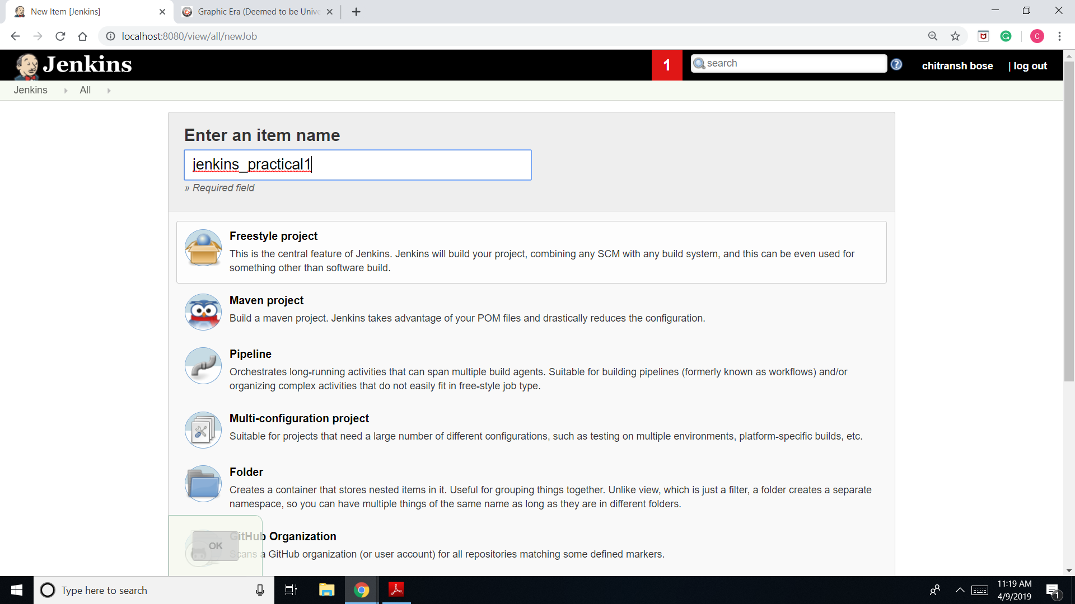

1. Go to configure and then choose build section.

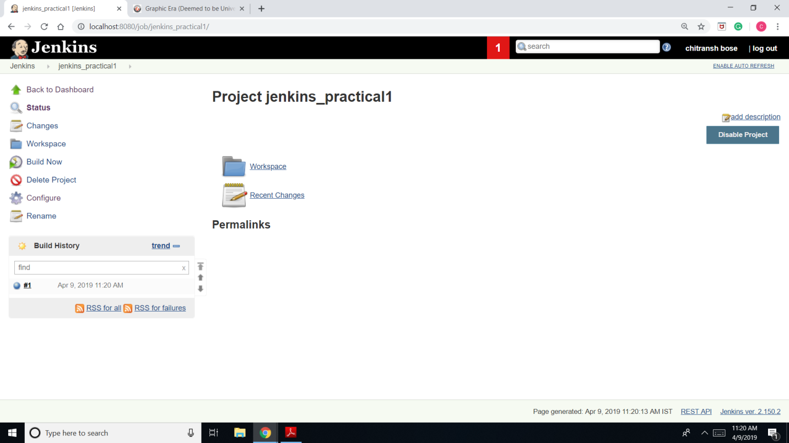

1. Go to build section then add build step and choose execute windows batch command.

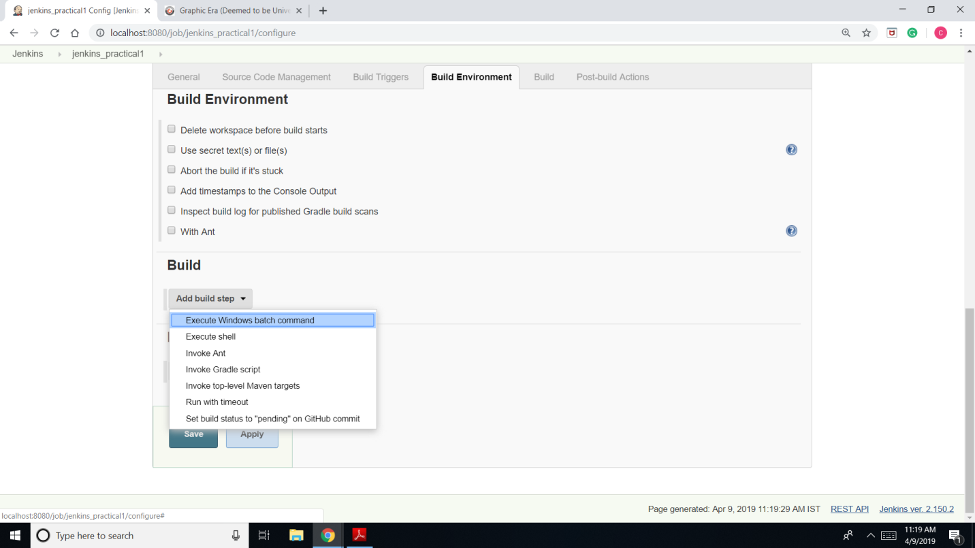

1. Echo “Jenkins_practical1” and save.

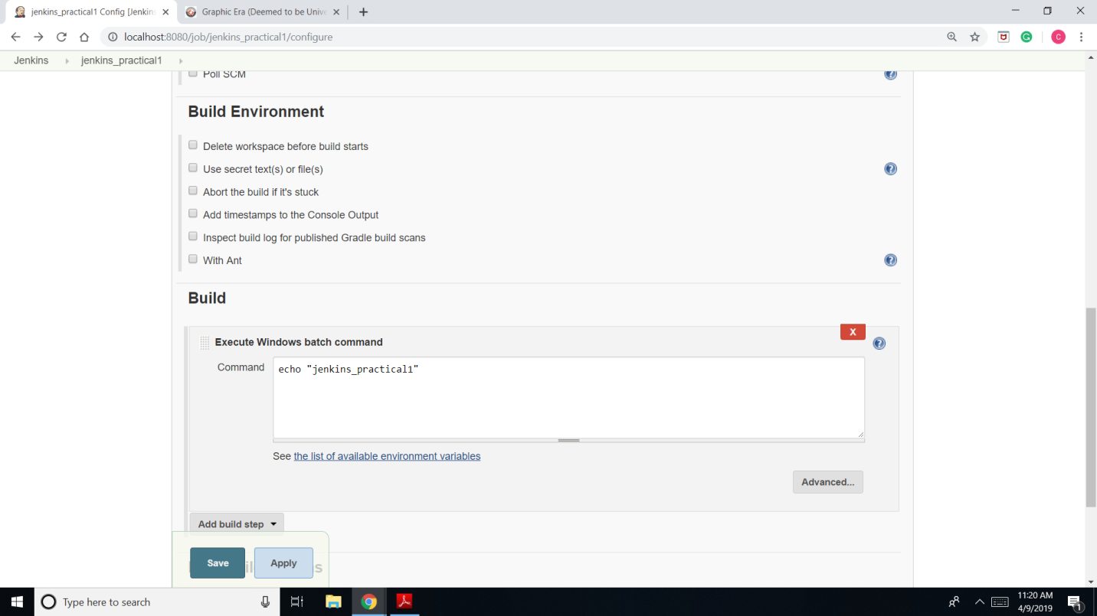

1. 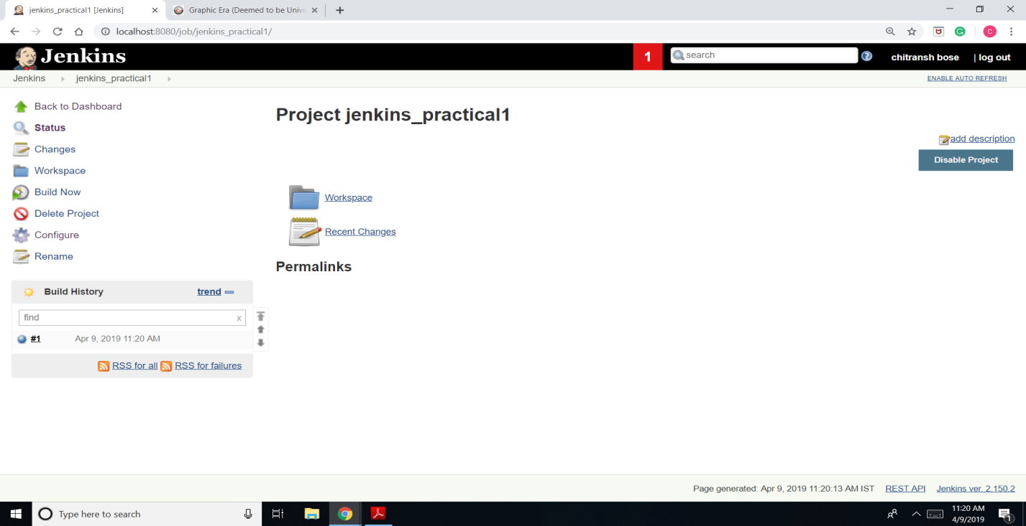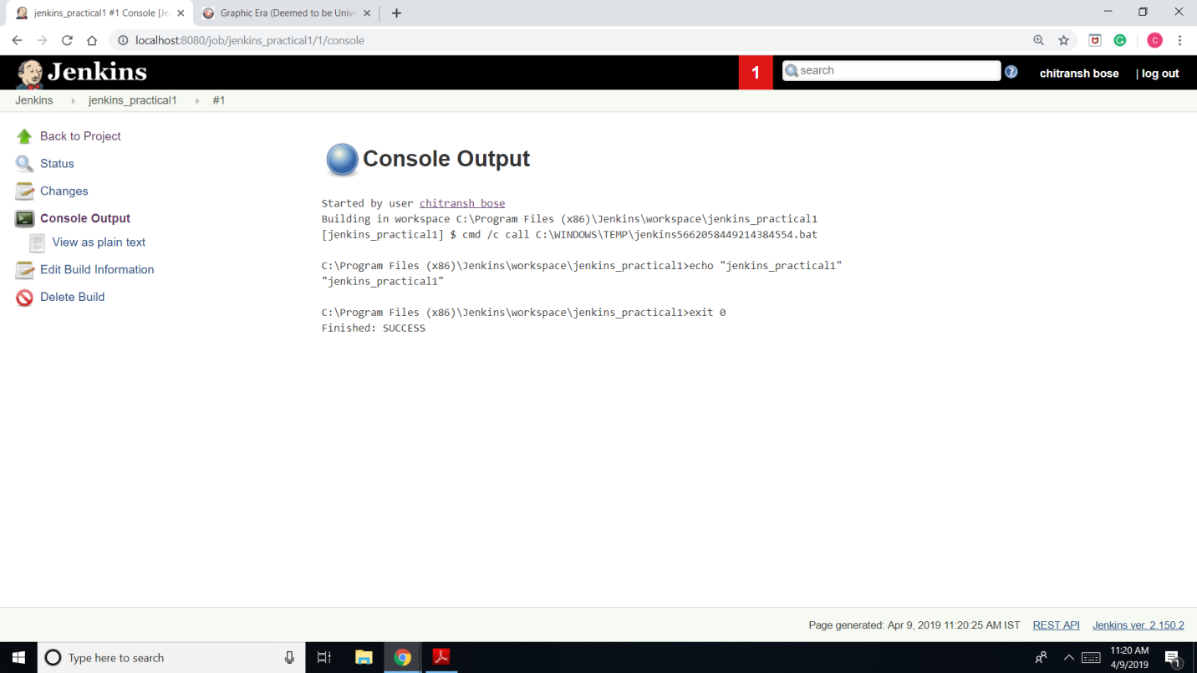Go to your project and click on build now and then go to console output to check the output.

Task 2b.

1. Create a job and choose a freestyle project.

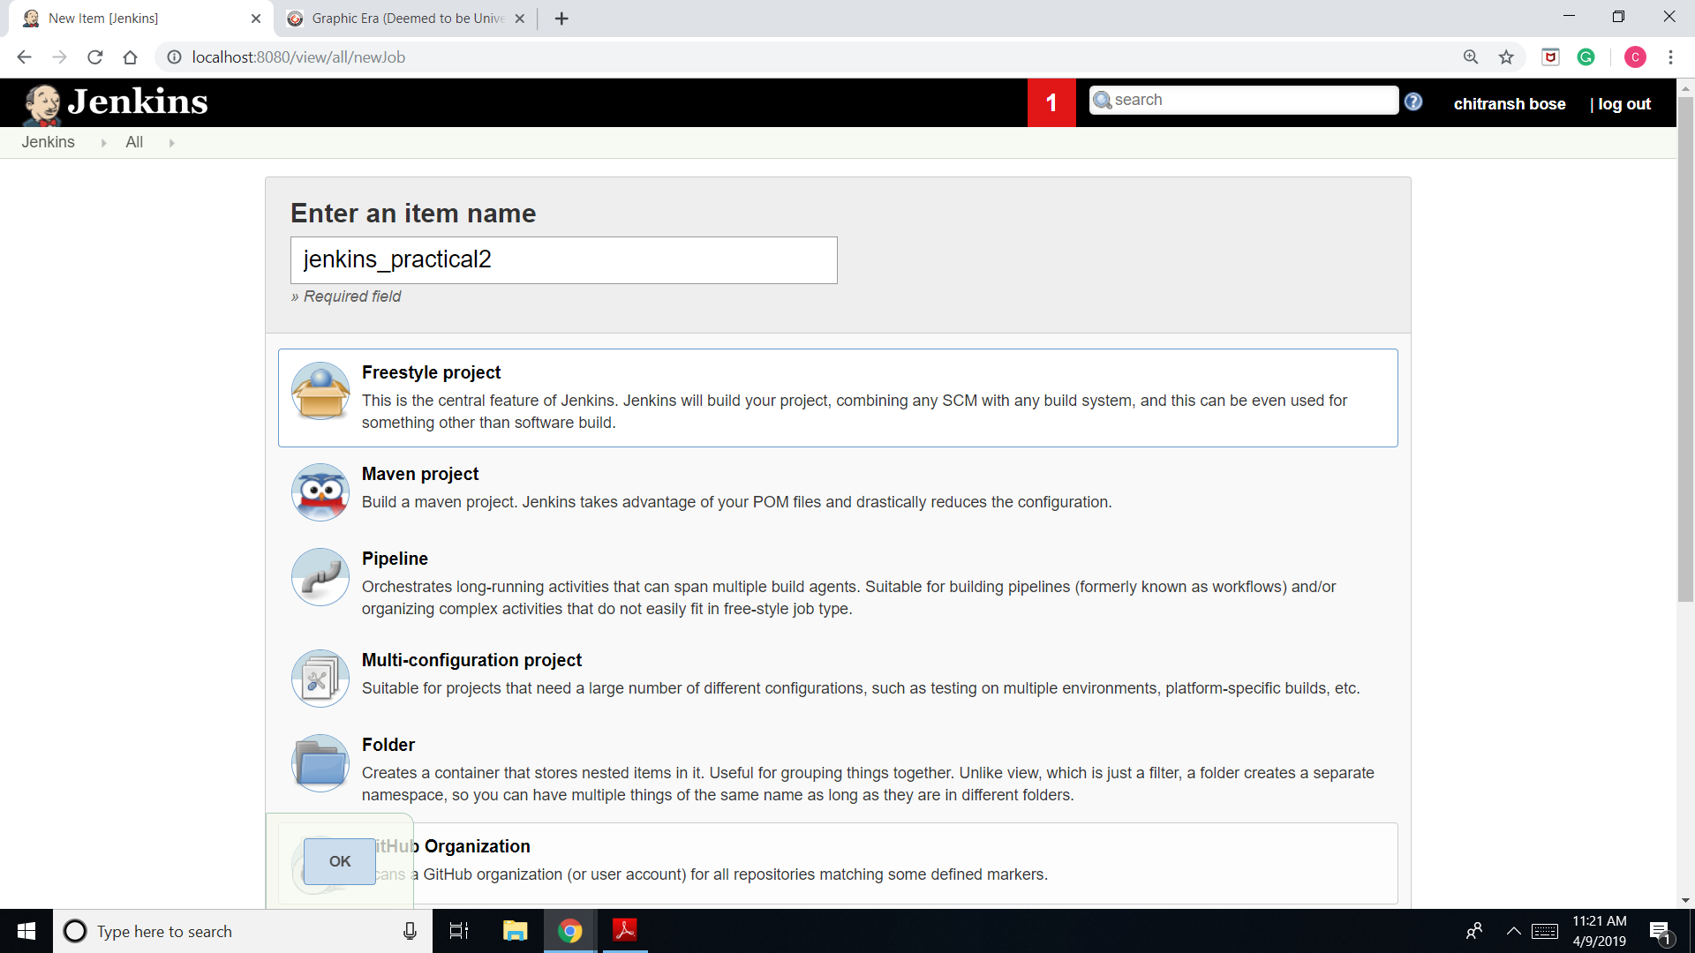

1. Go to configure.

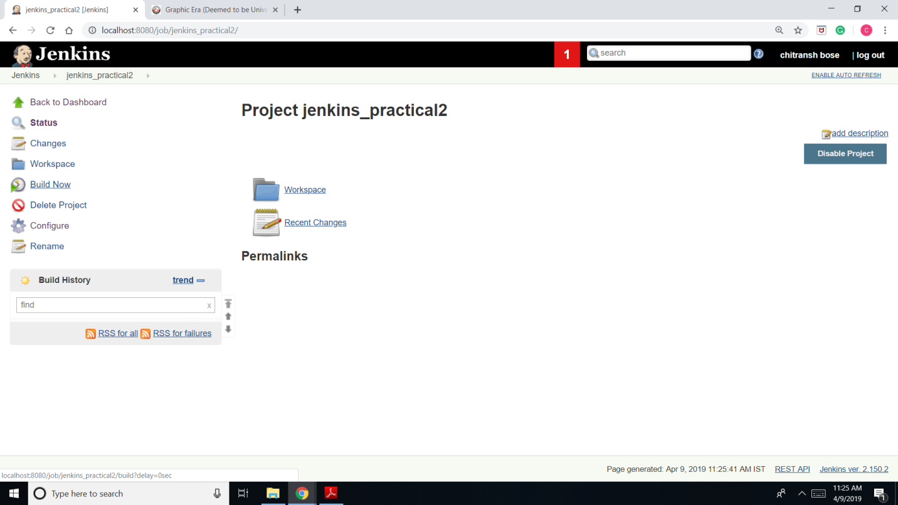

1. Go to build environment and add build step as execute windows batch command and in the command writing area write “date >> C:\jenkins_2.txt” and save.

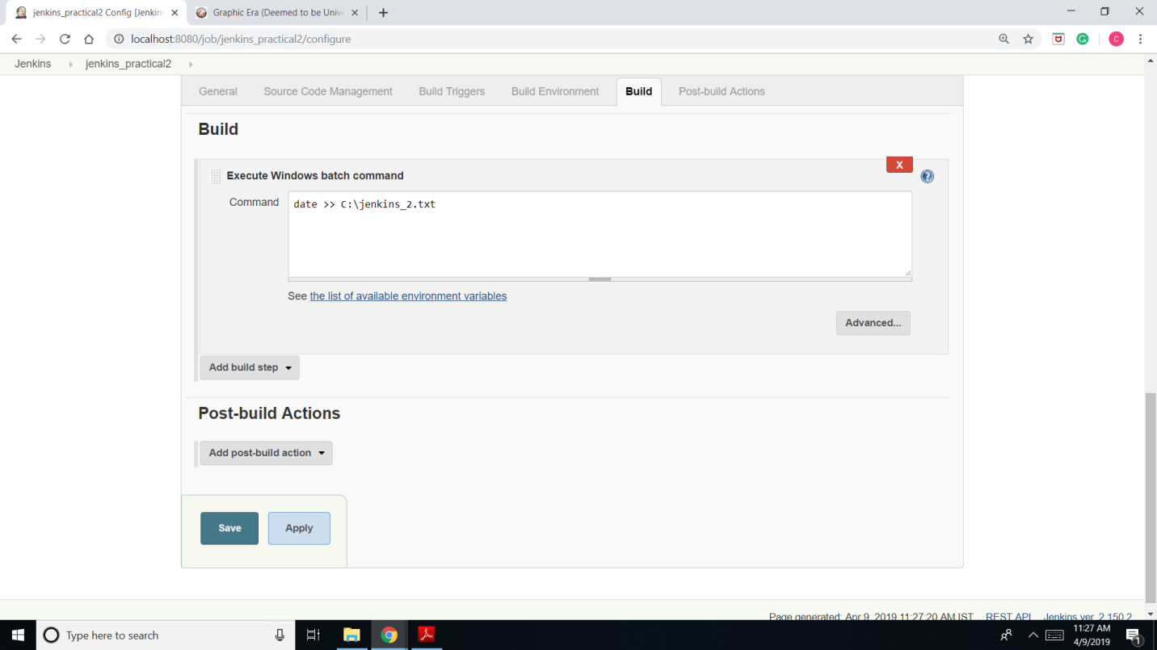

1. Build the project.

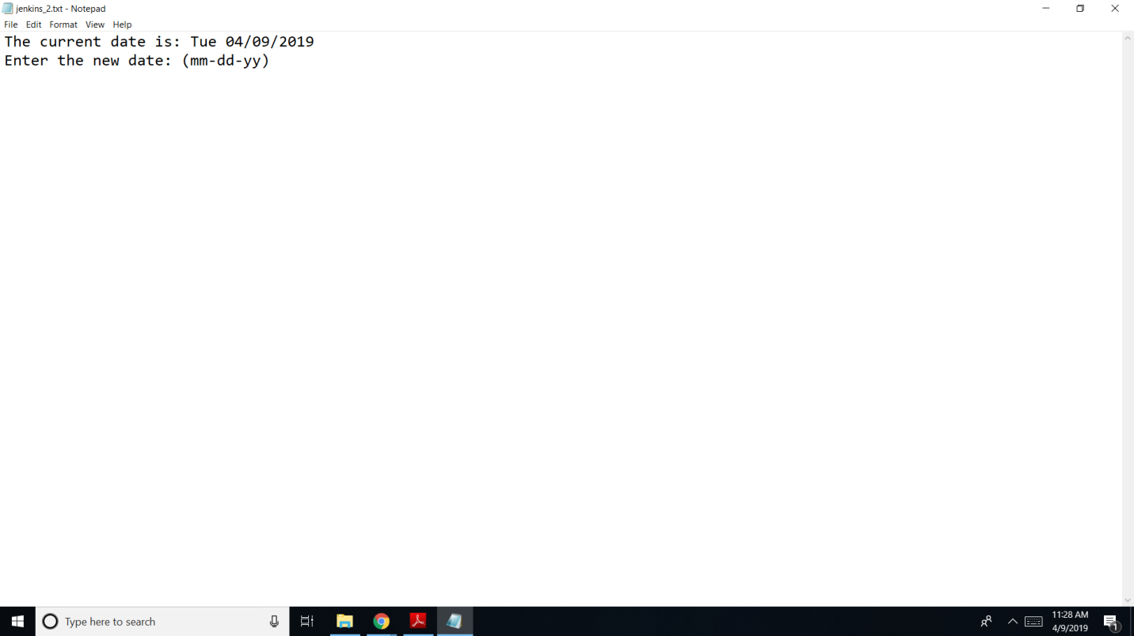

Task 2c.

1. Go to “manage Jenkins”.

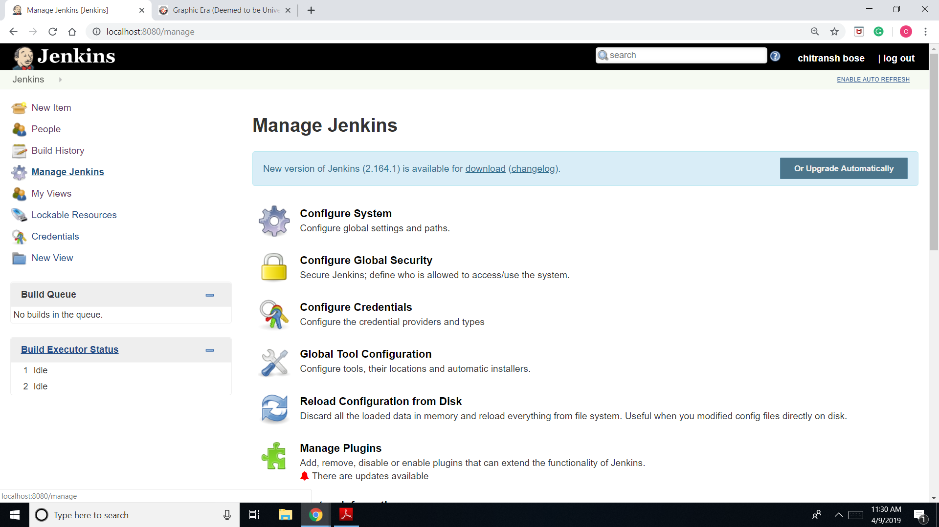

1. 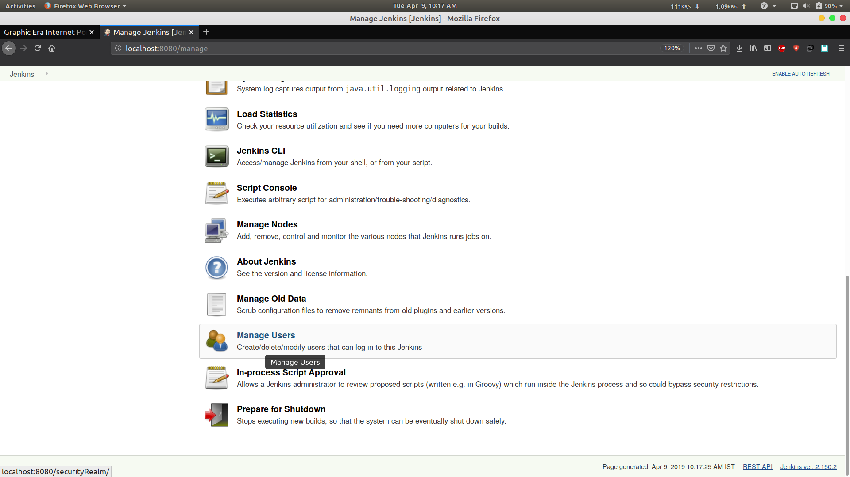Go to “manage users”.
2. Click on create user and enter the details.

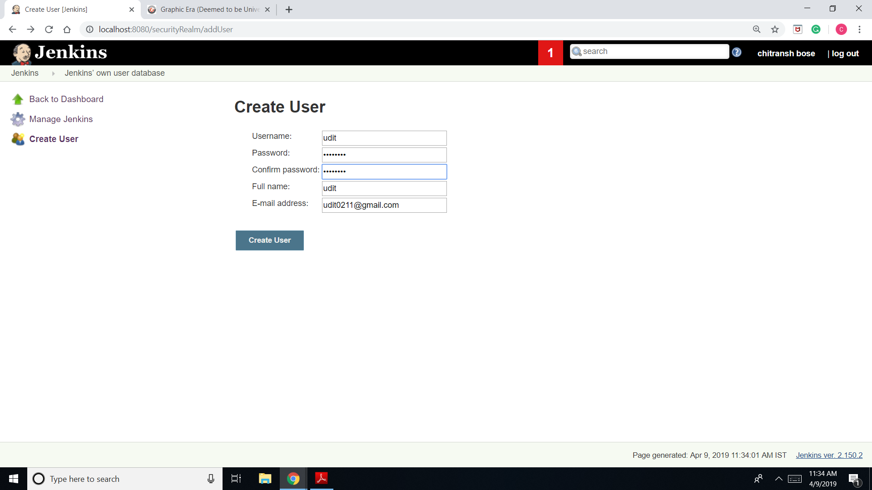

1. Click on create user and the user is created.

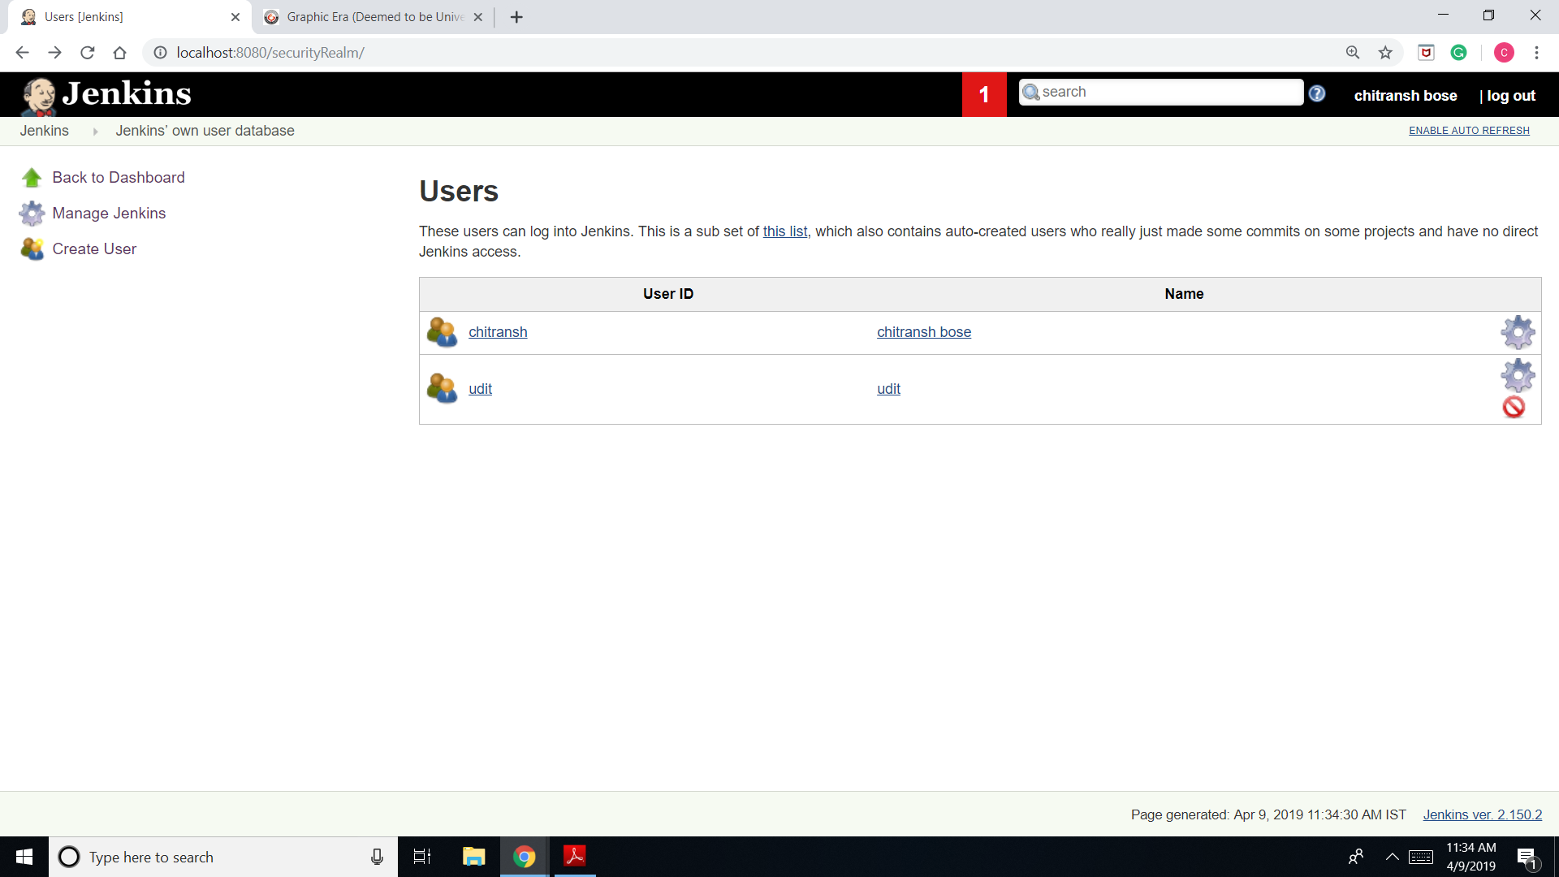Task 2d.

1. Go to “manage Jenkins” and click on “configure global security”.

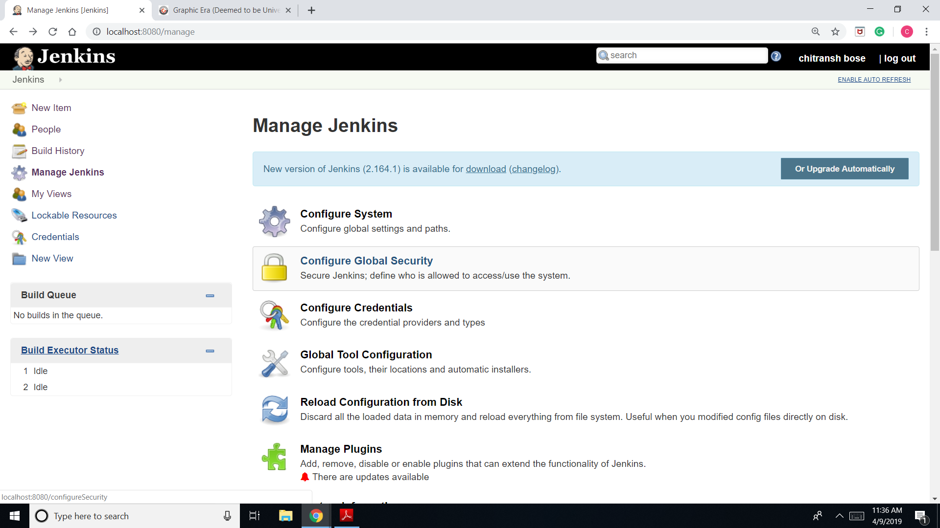

1. 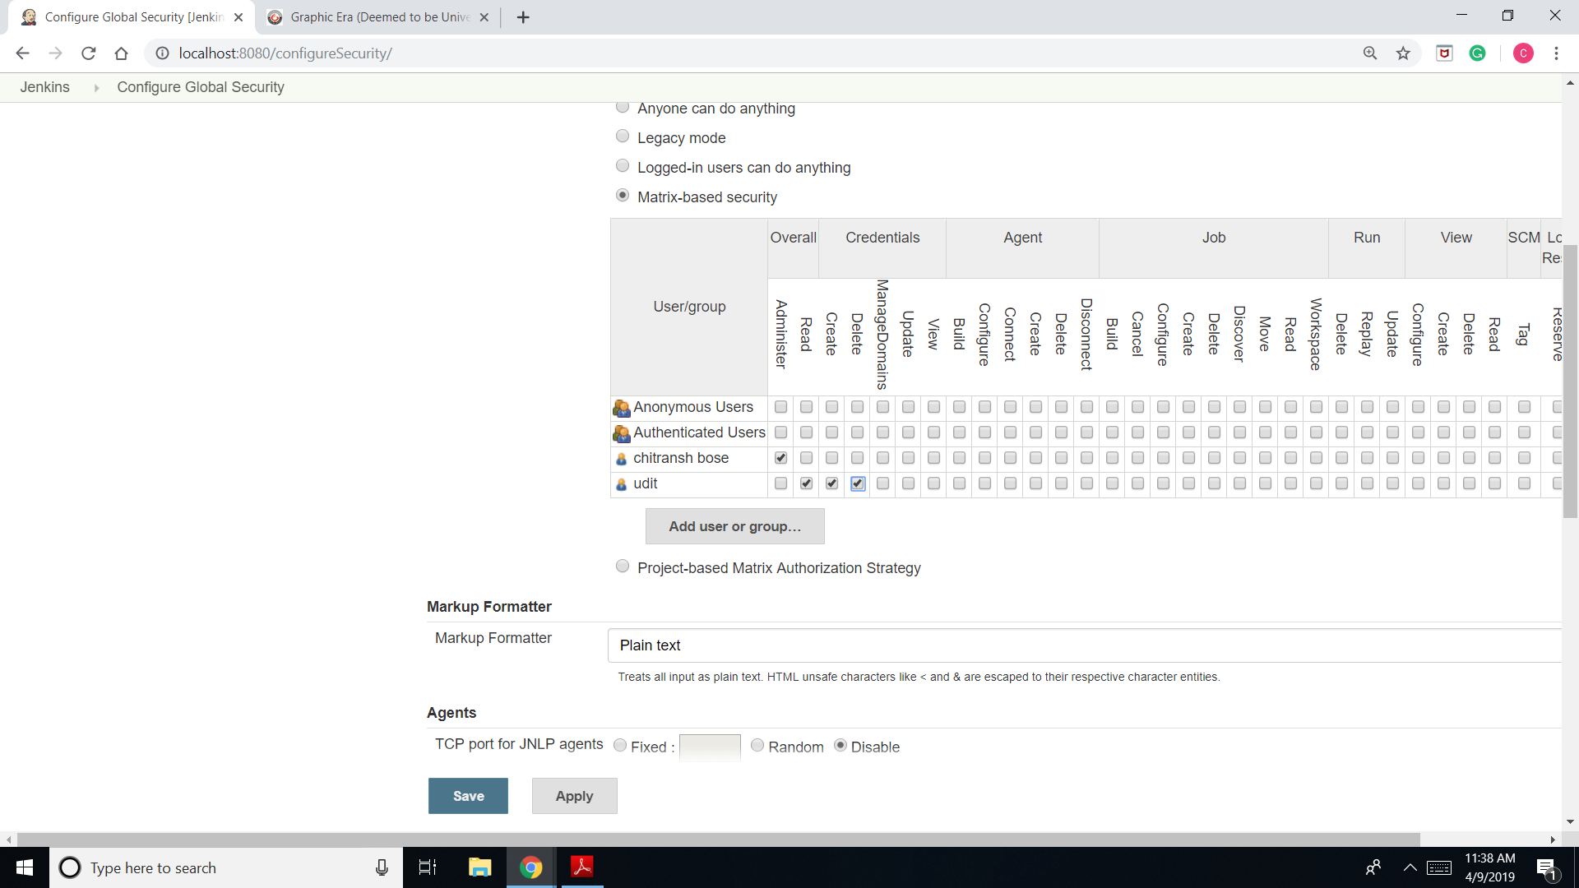Go to “authorization” and then to “matrix-based security”.
2. Add the user, assign privileges and login in with another account.

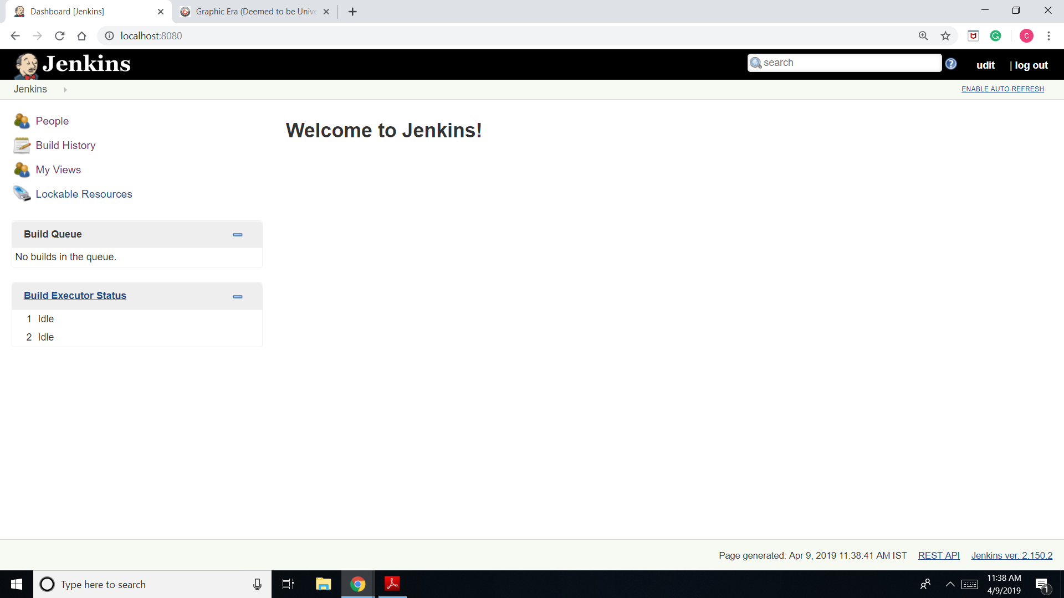

Task 2.e

1. Go to “manage Jenkins” and then “manage plugins”.

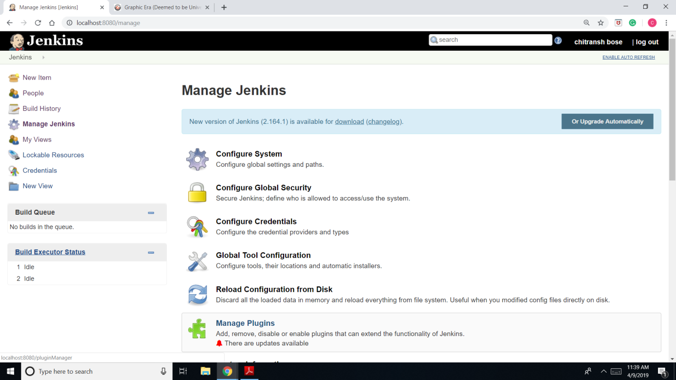

1. 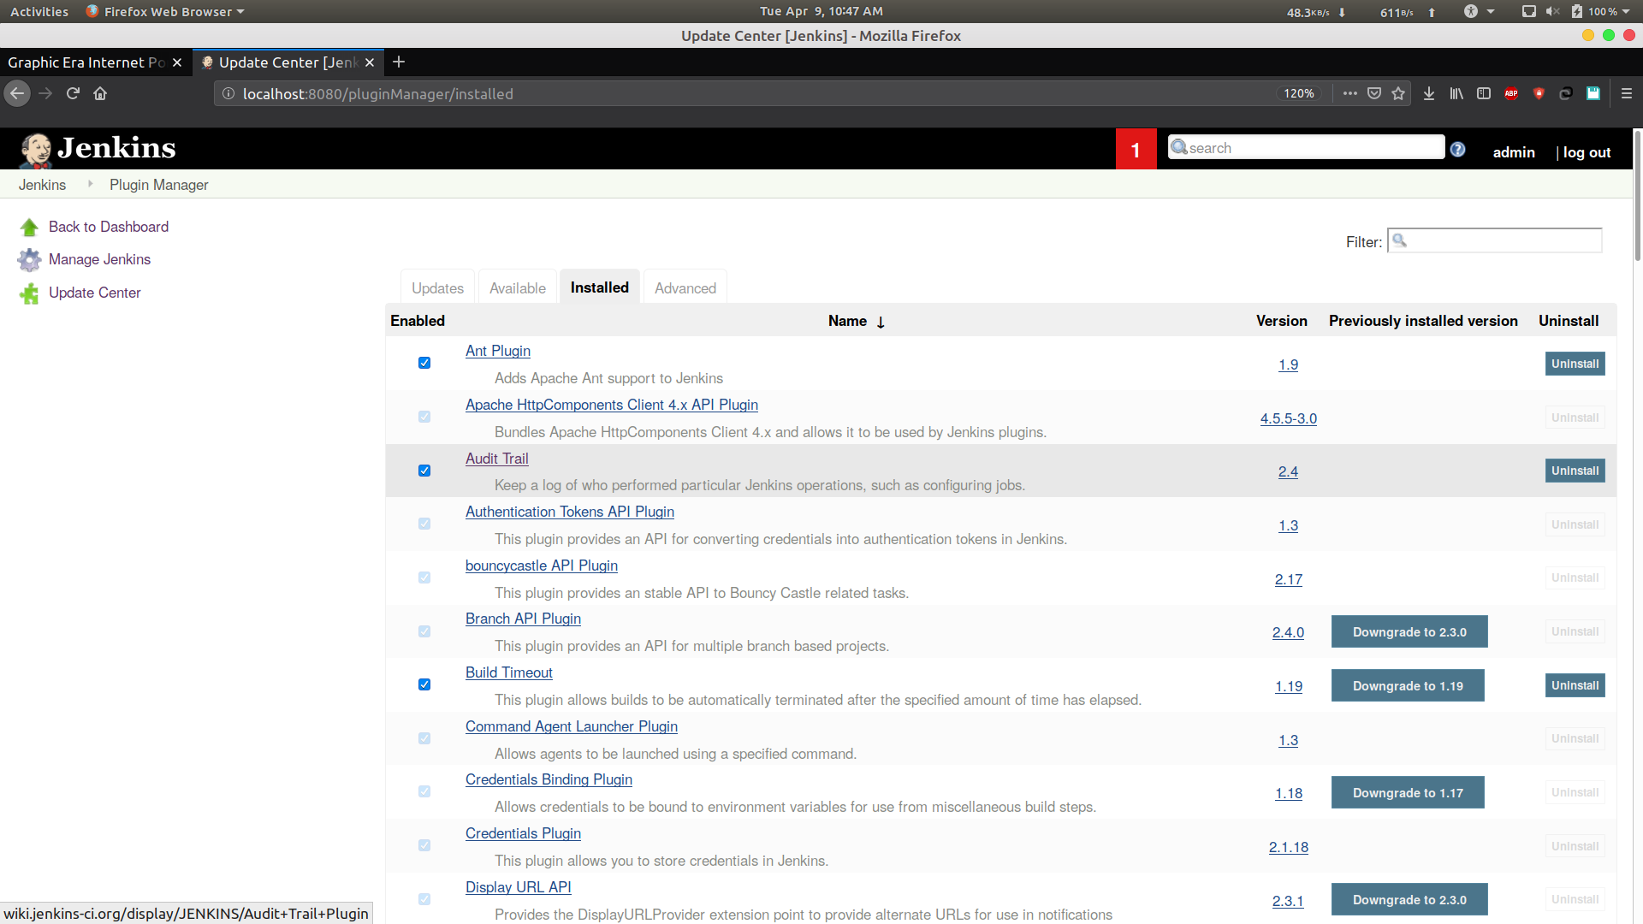Choose “Audit trail” and install it.
2. Go to “manage Jenkins” and then “configure system”.

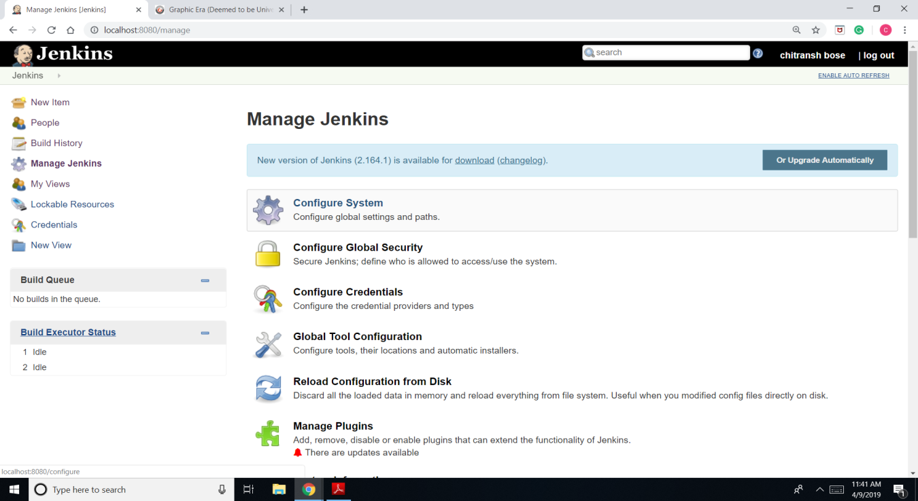

1. Go to “global properties” and further to “Audit trail”.

-> In Add Logger option, choose log file.

->Add log location.

->Add log file size: 25MB.

->Add log file count: 5.

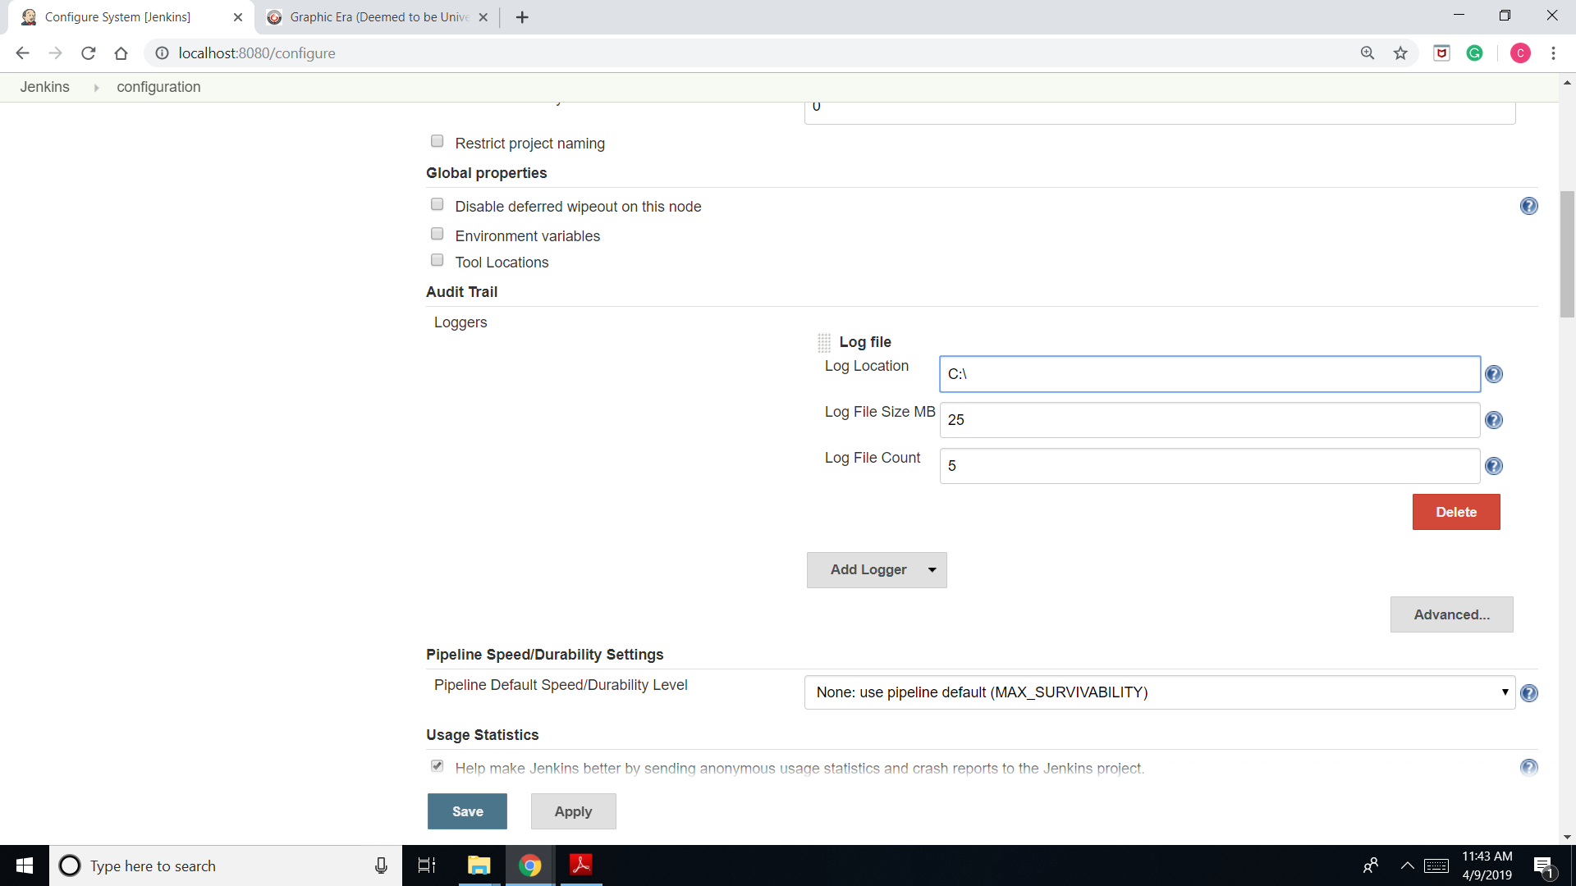

1. Build a job and the log file.

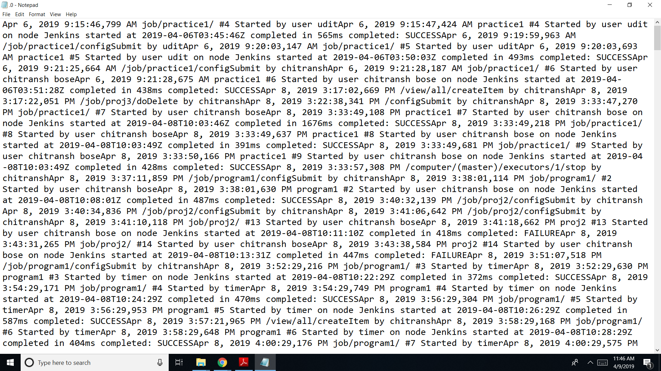

Task 2f.

1. Go to “manage Jenkins” and then to “configure system”.

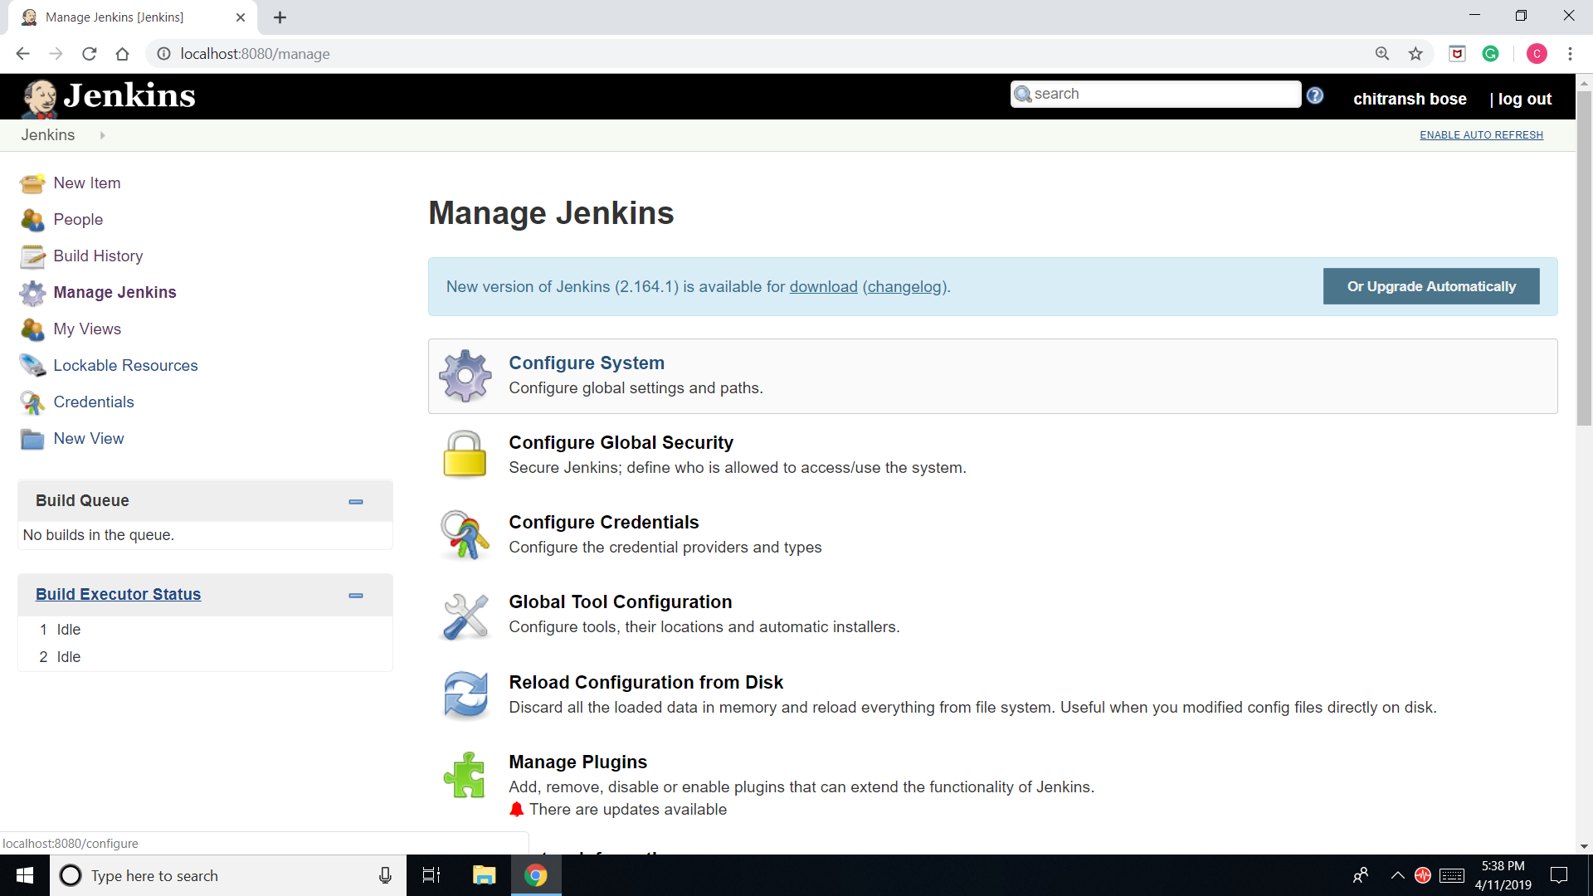

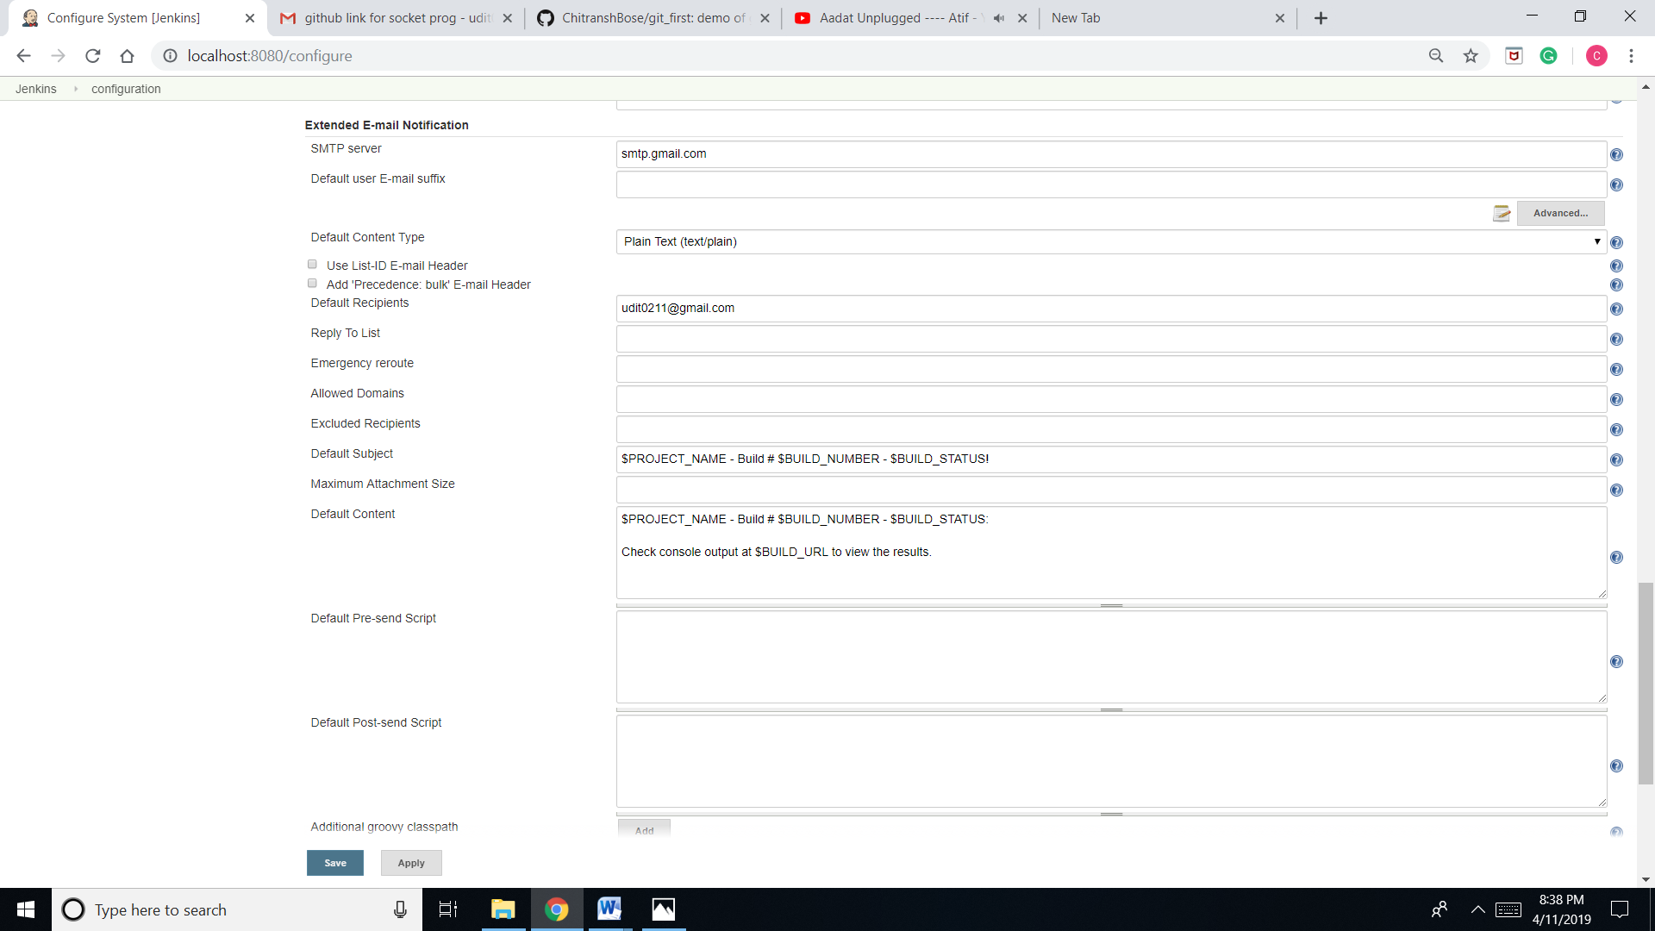2. Go to “extended e-mail notifications”.

3. Click on advance and enter a username, password, SMTP port and default recipients.

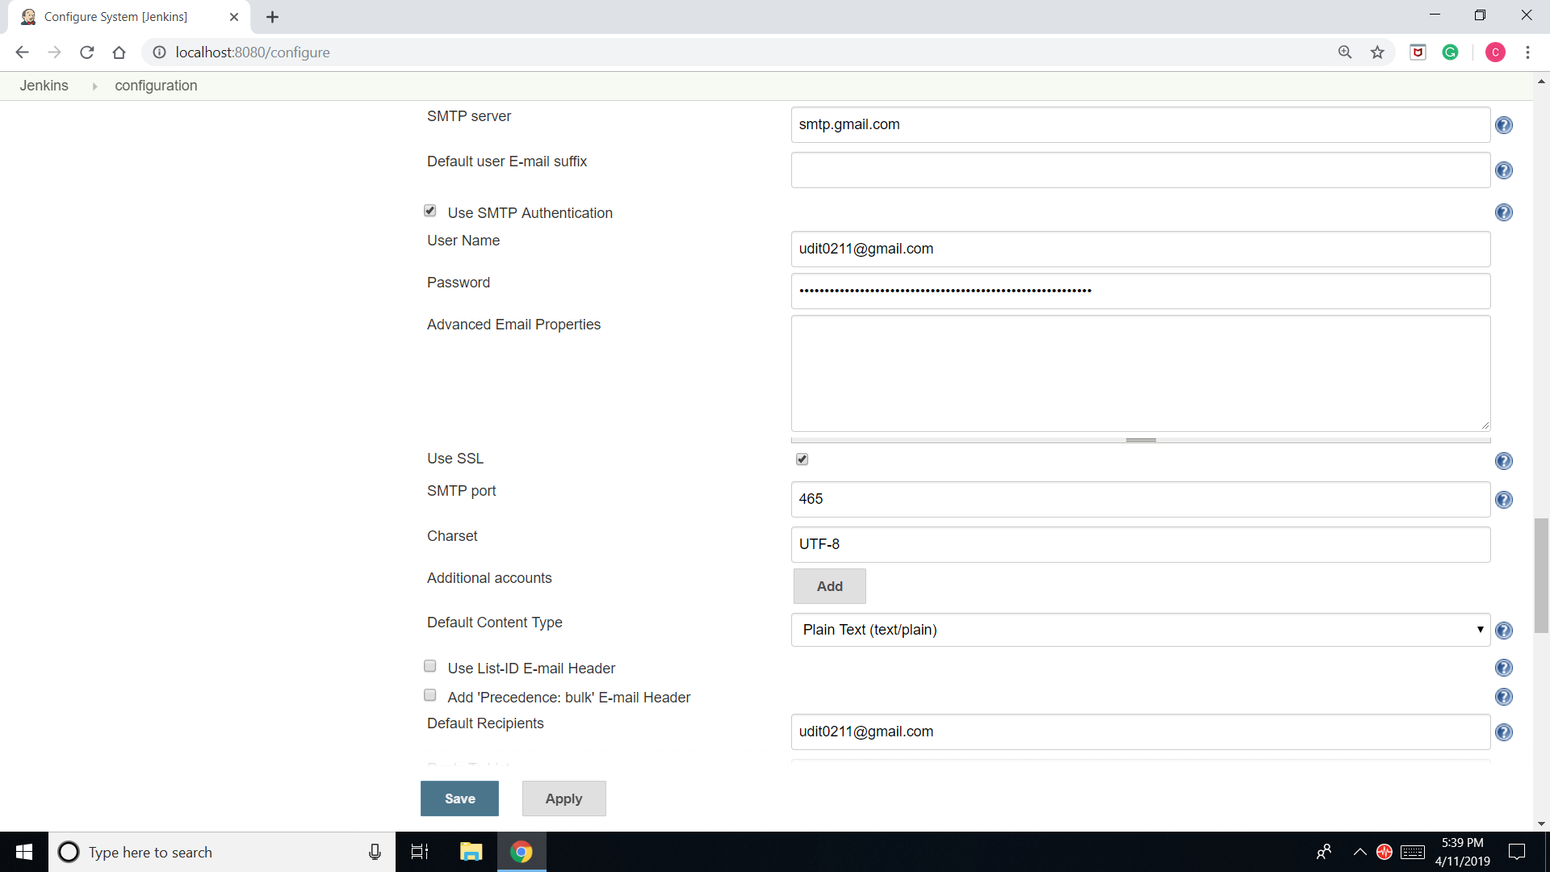

Task 2g.

1. 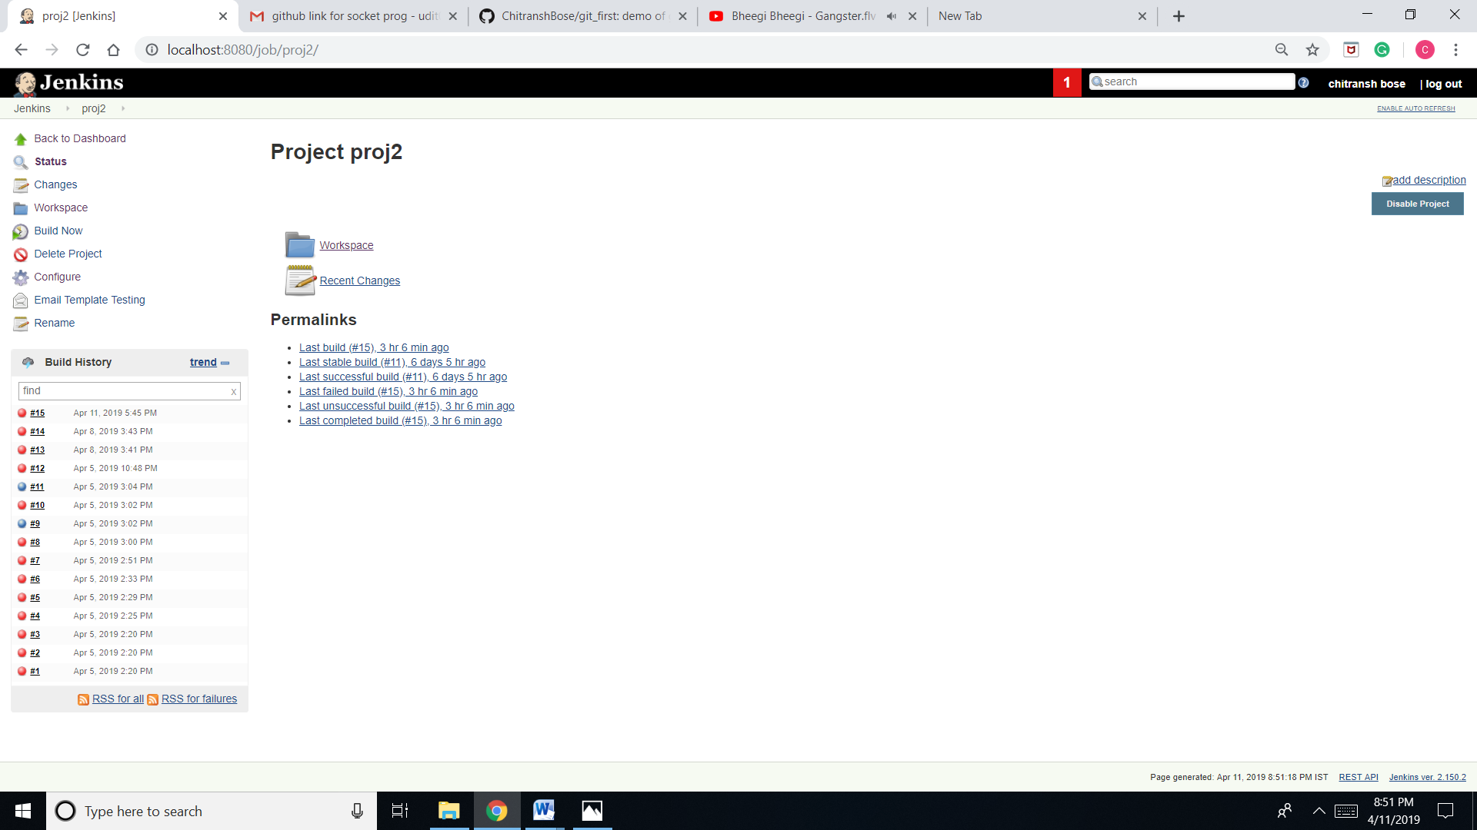Choose any job and go to configure.
2. 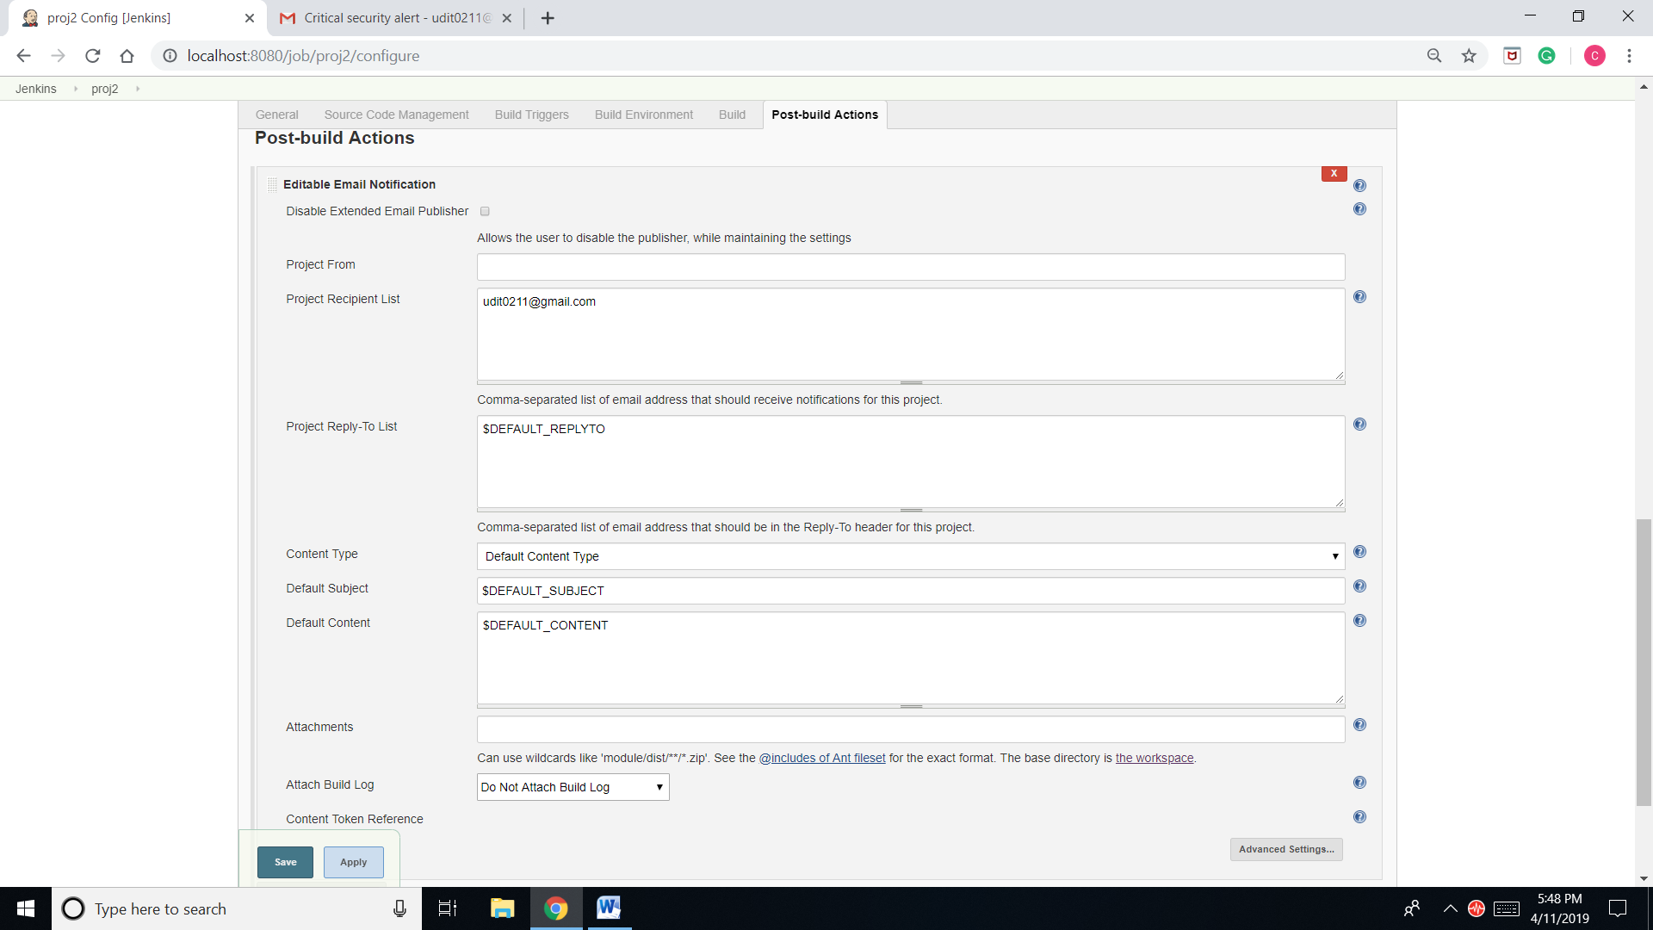Go to “post-build actions”. In “editable email notification enter the “project recipient list”.
3. Click on “advance” and go to “trigger” and then add triggers:

->Developers.

->Recipient list.

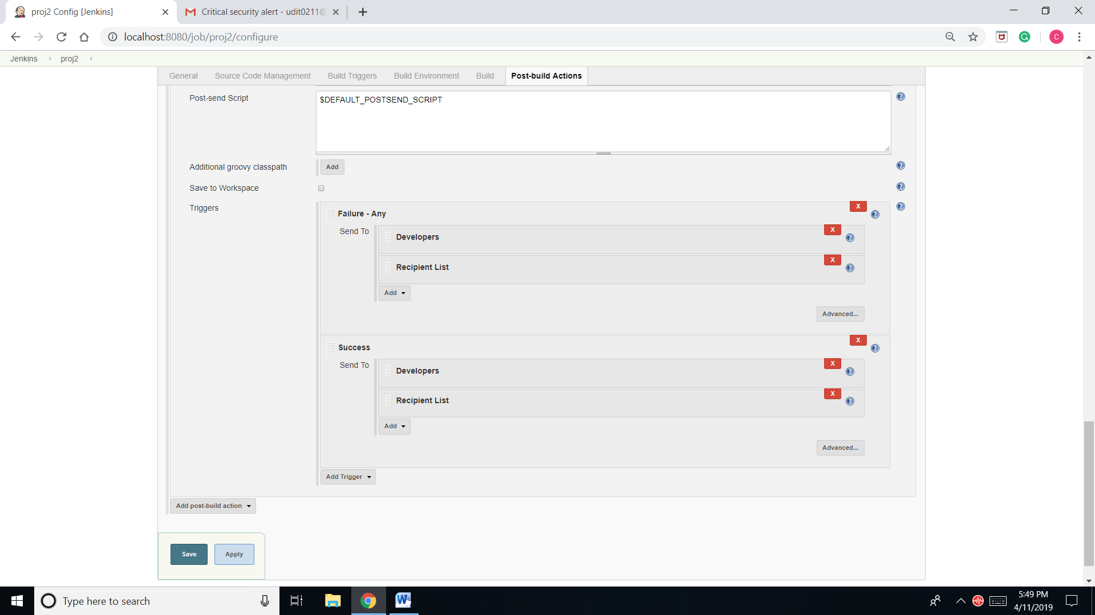

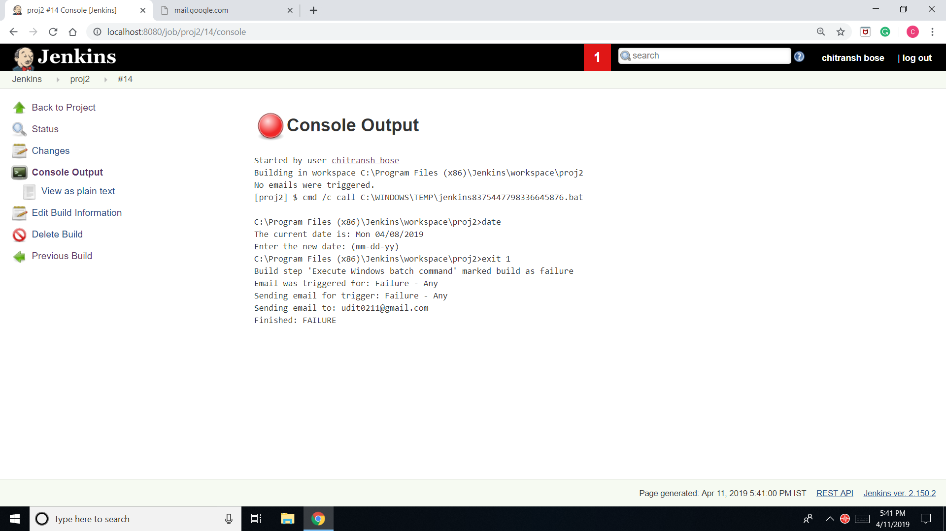

1. 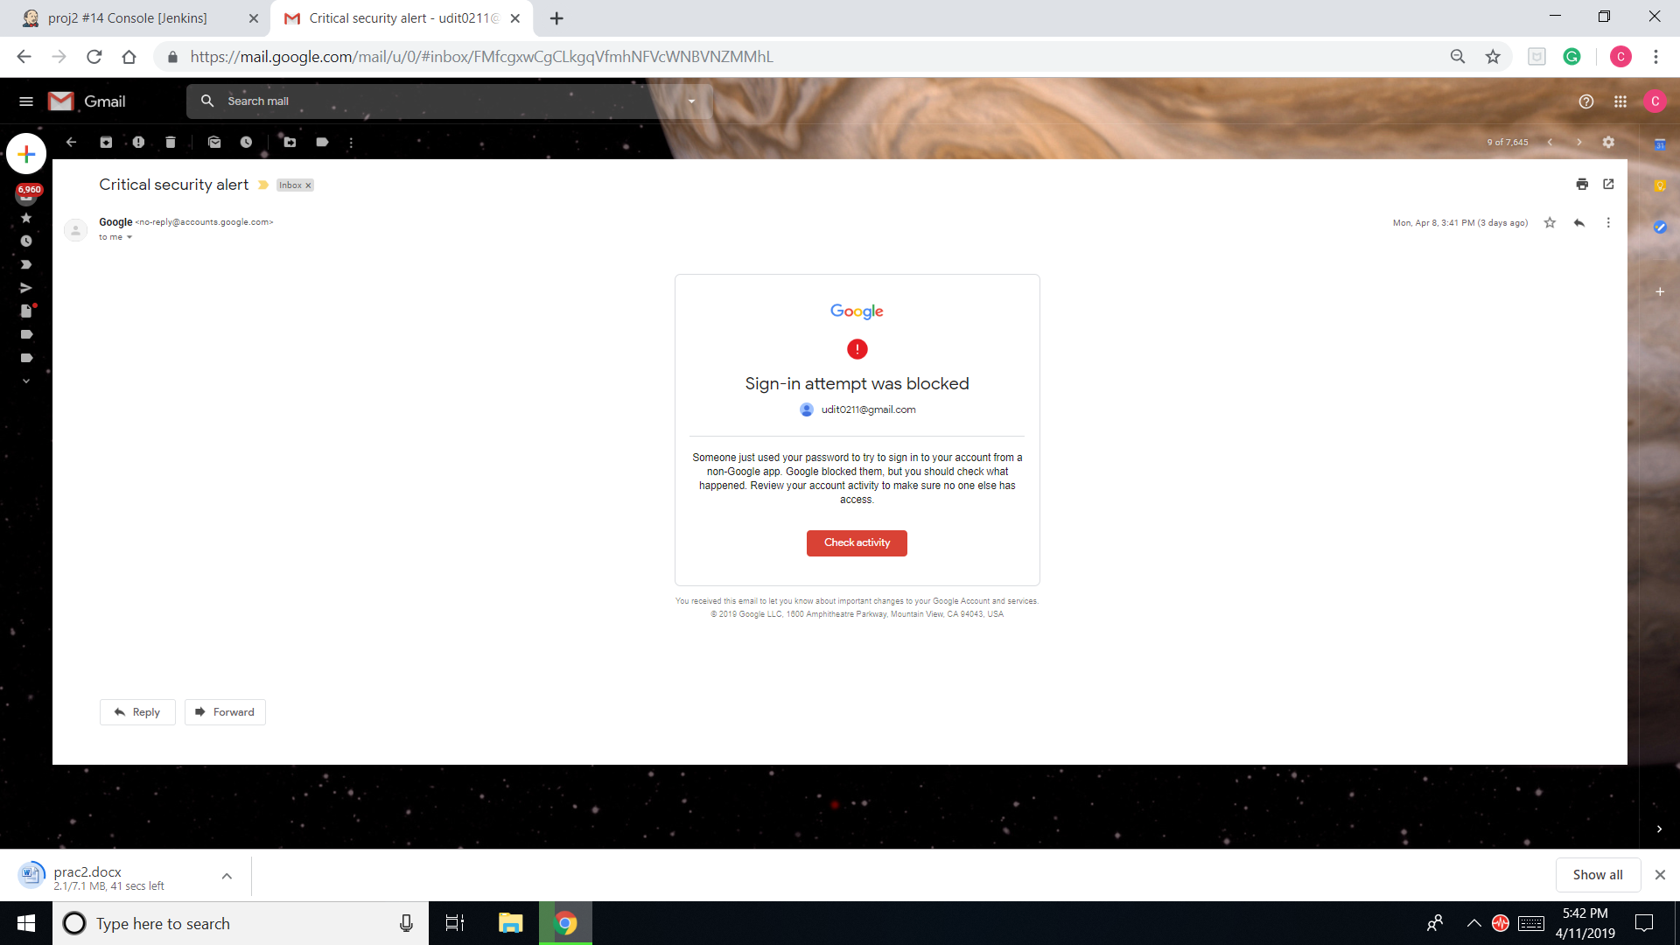Go to “console output” to see the output and check the mail.

Task 2h.

1. Choose any job and click configure.

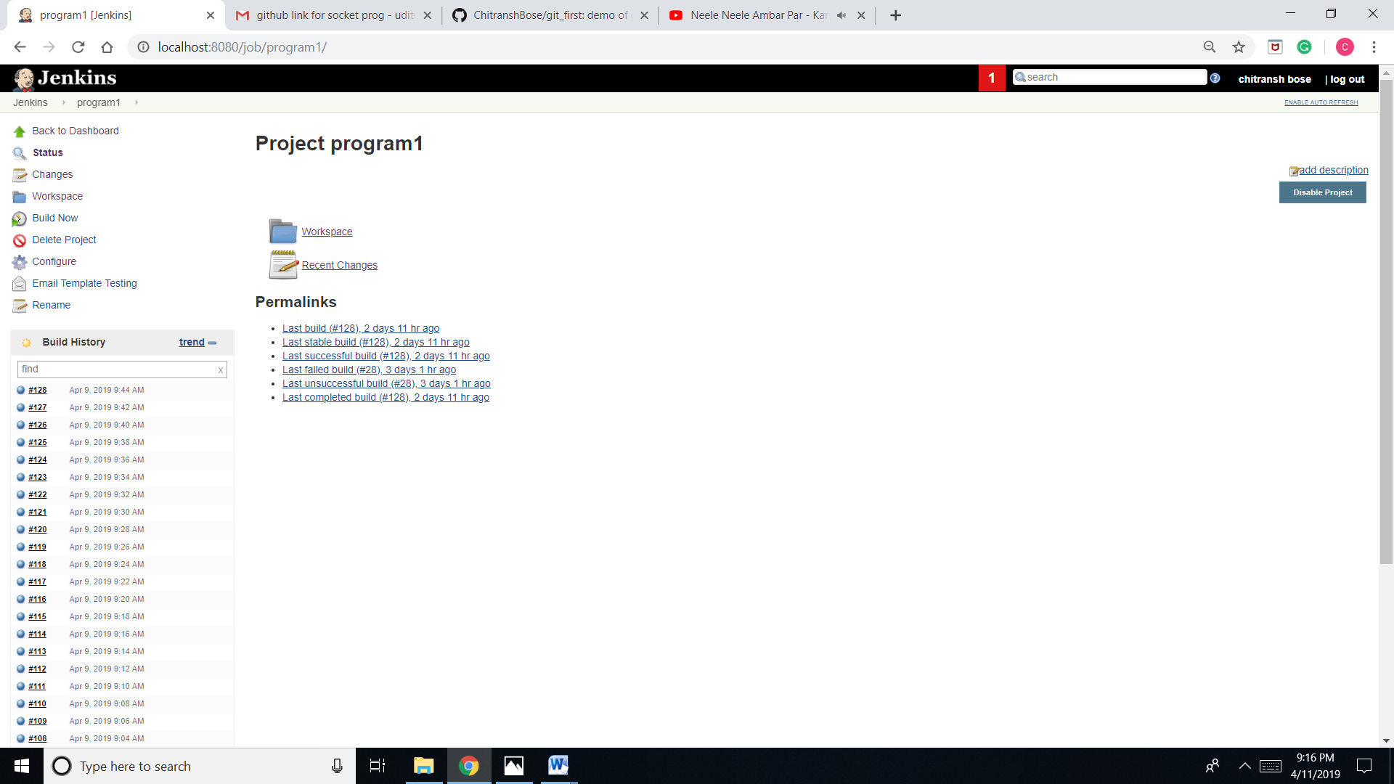

1. 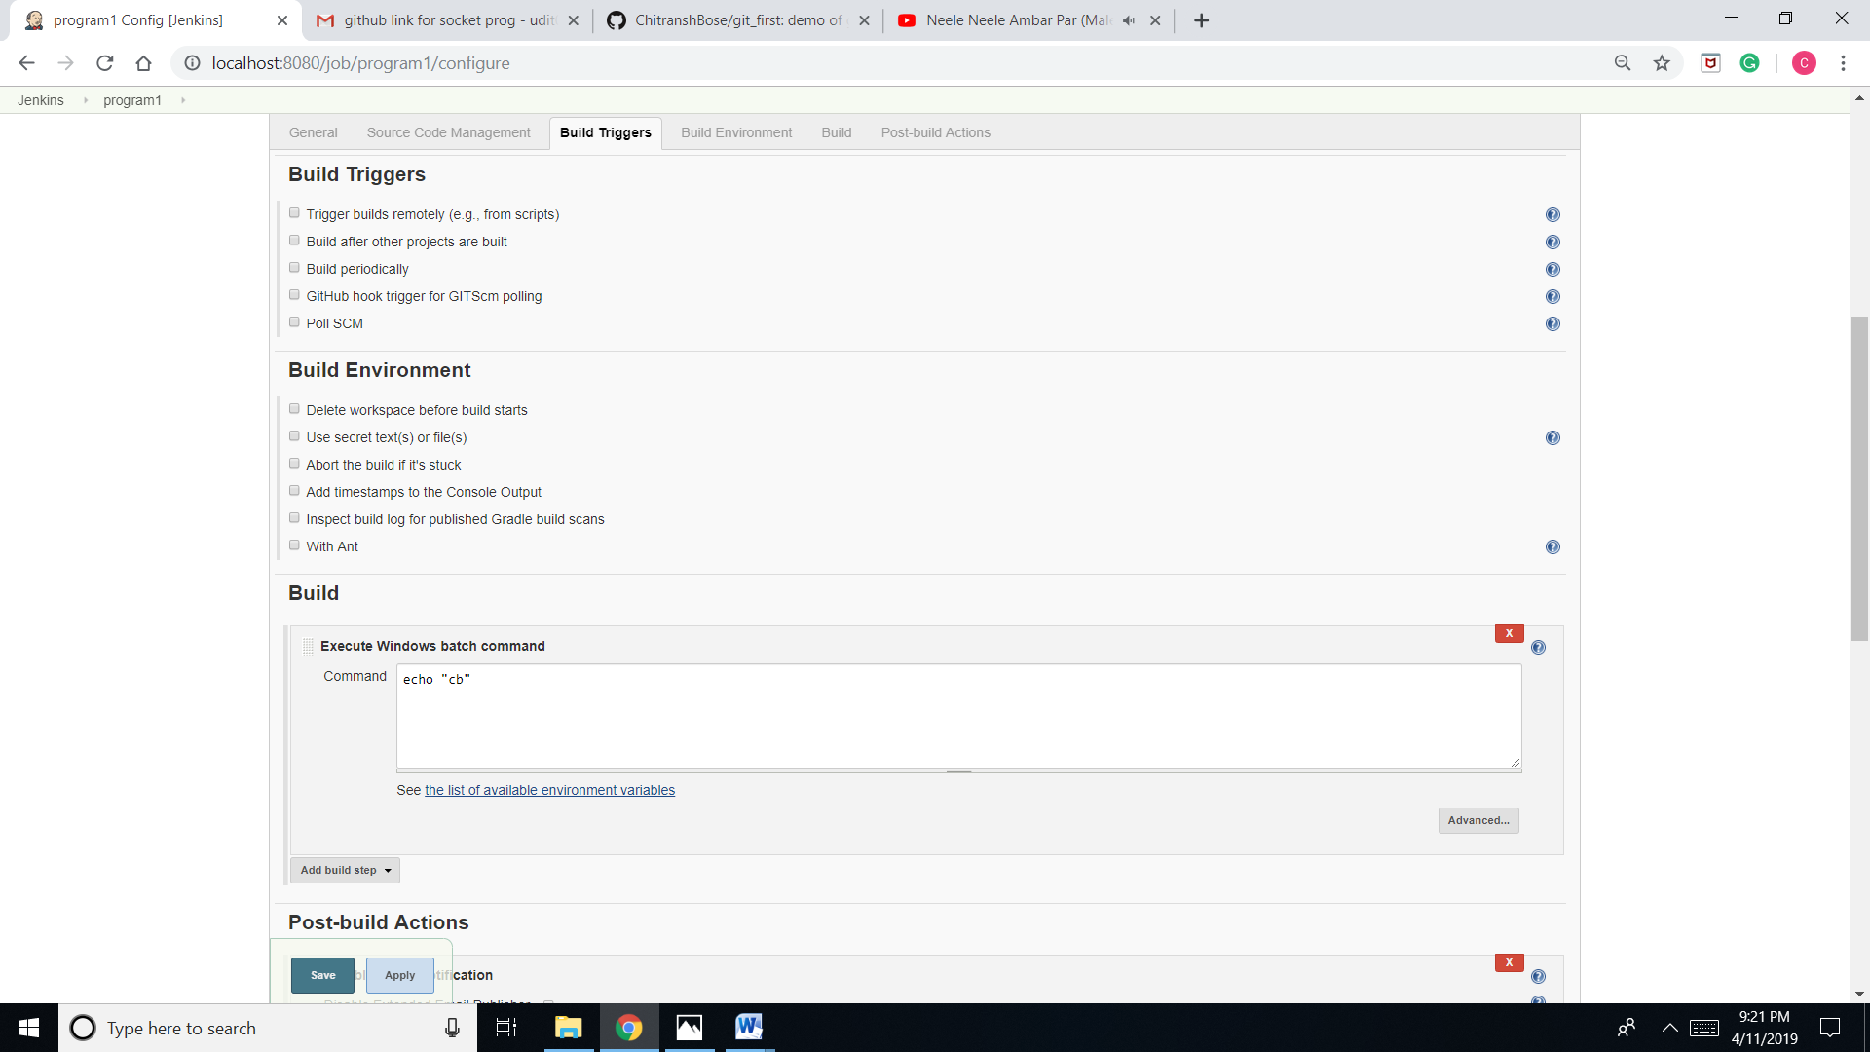Go to “Build Trigger”.
2. 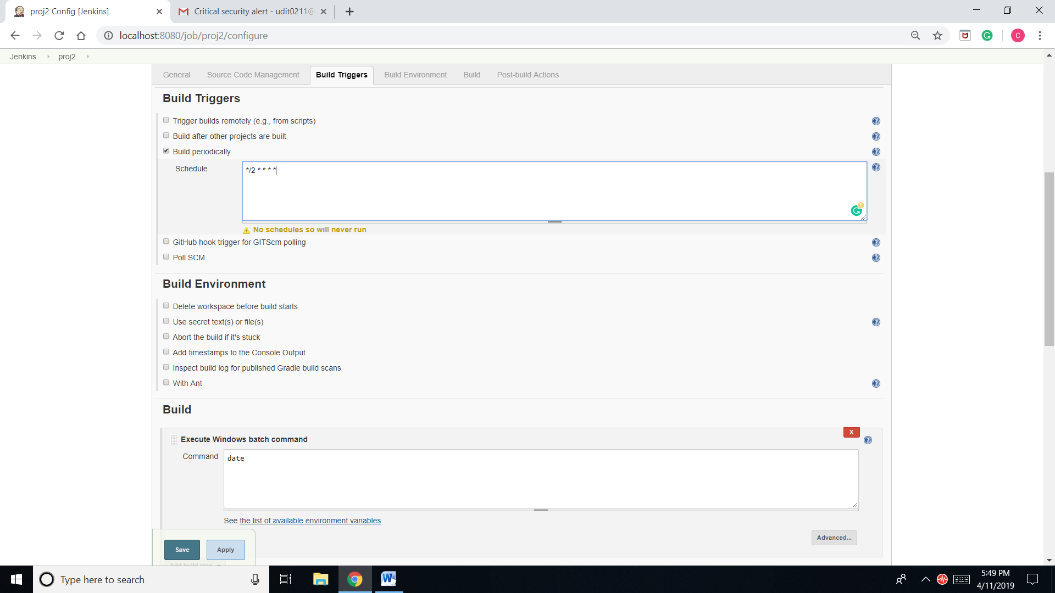Click on “build periodically” and type: */2 * * * *.

1. 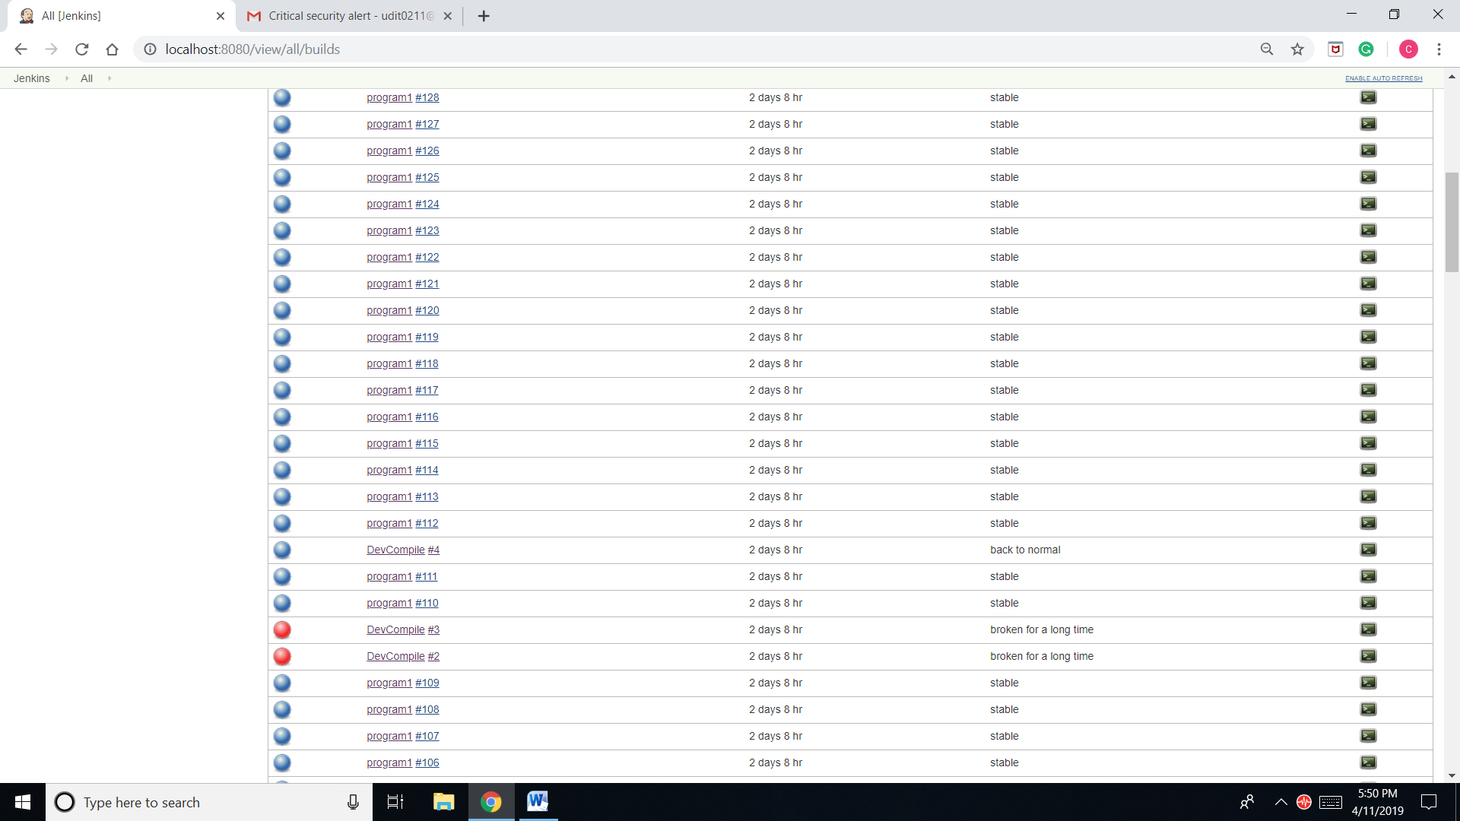Check the build history.

Task 2i.

1. 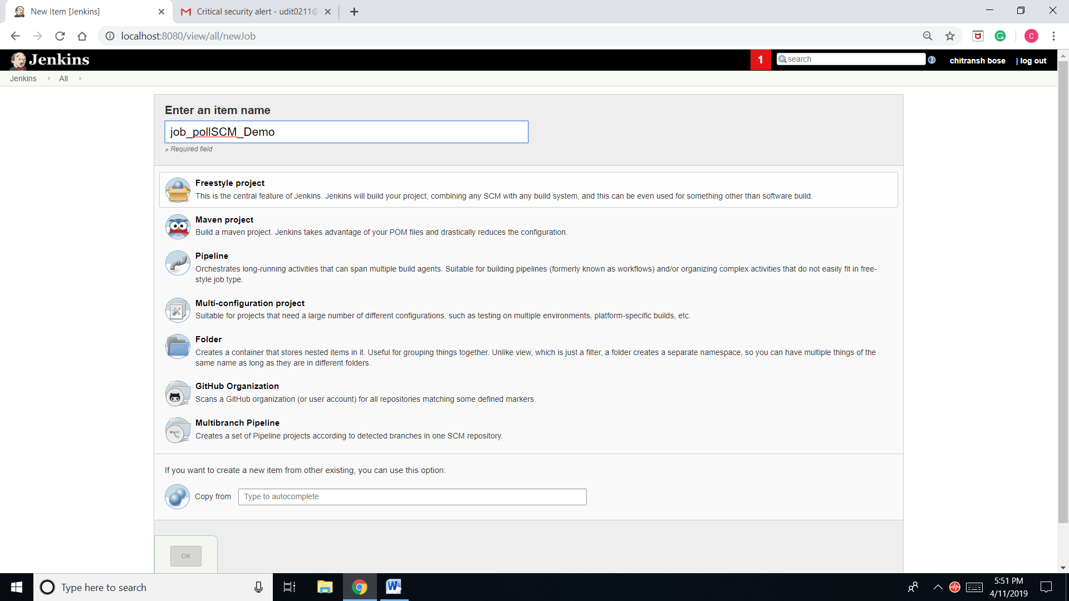Create job “job_pollSCM_Demo” and click on freestyle project.
2. Click on configure and then to “source code management”.

->Choose git.

->Enter the URL of the repository.

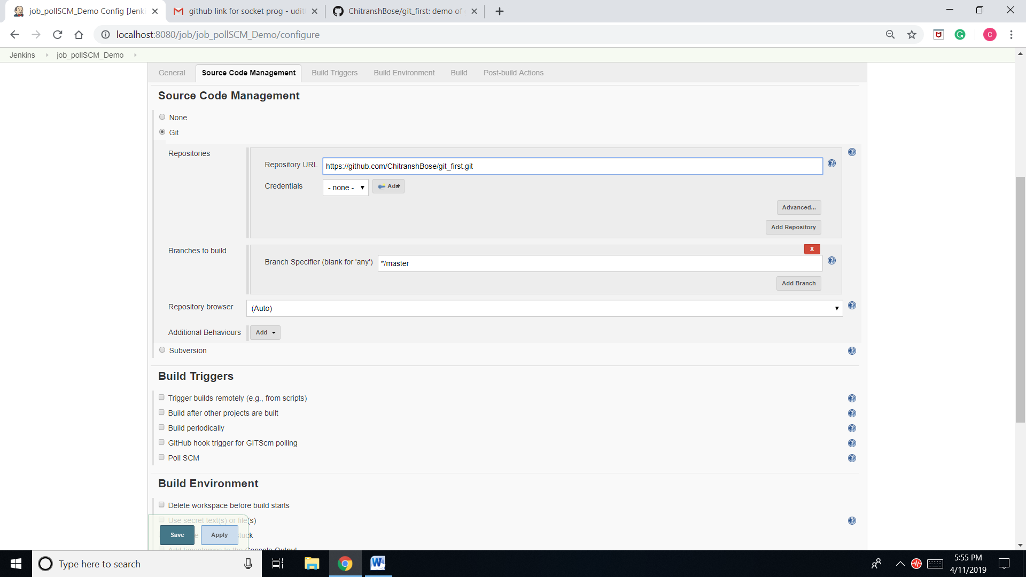

1. Clicks on configure and then “build trigger”.
2. Click on Poll SCM and schedule */2 * * * *.

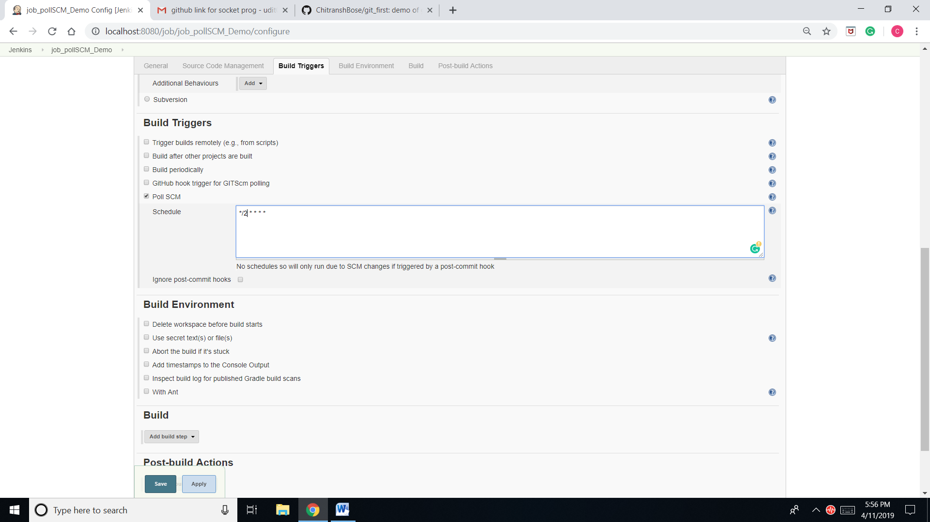5

1. 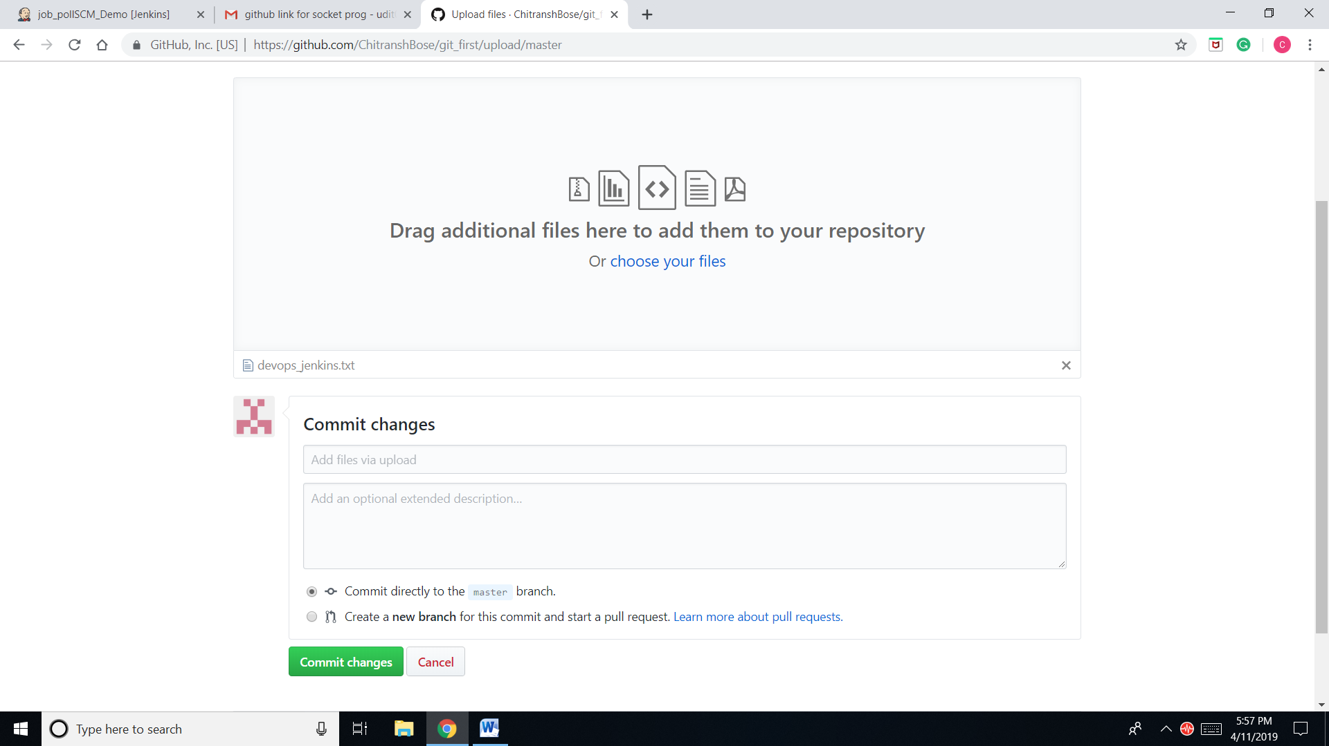Push the file in the GitHub repository and commit it.
2. Go to workspace.

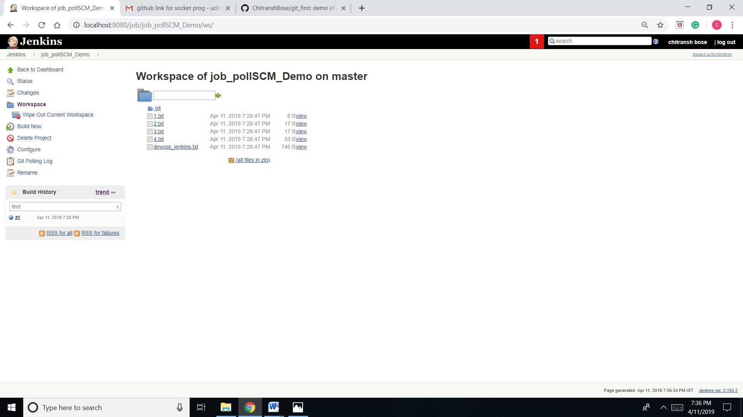

Task 2j.

1. Create a project “DevCompile” and choose freestyle.

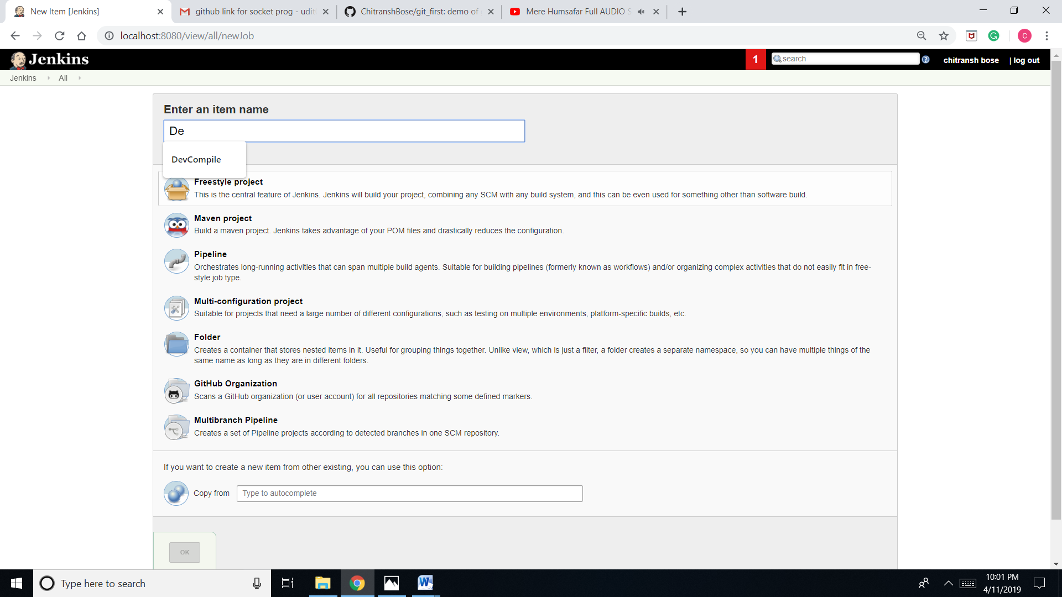

1. Go to configure and then “source code management” and enter the link of git repository: <https://github.com/edureka-git/DevOpsClassCodes.git> and save it.

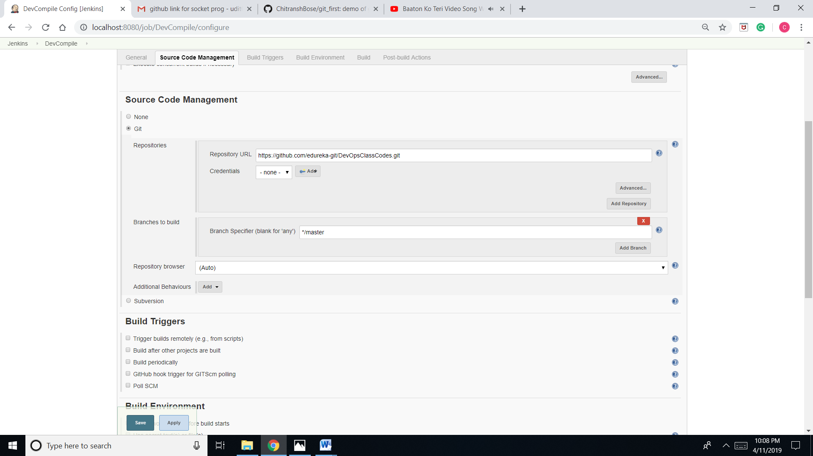

1. 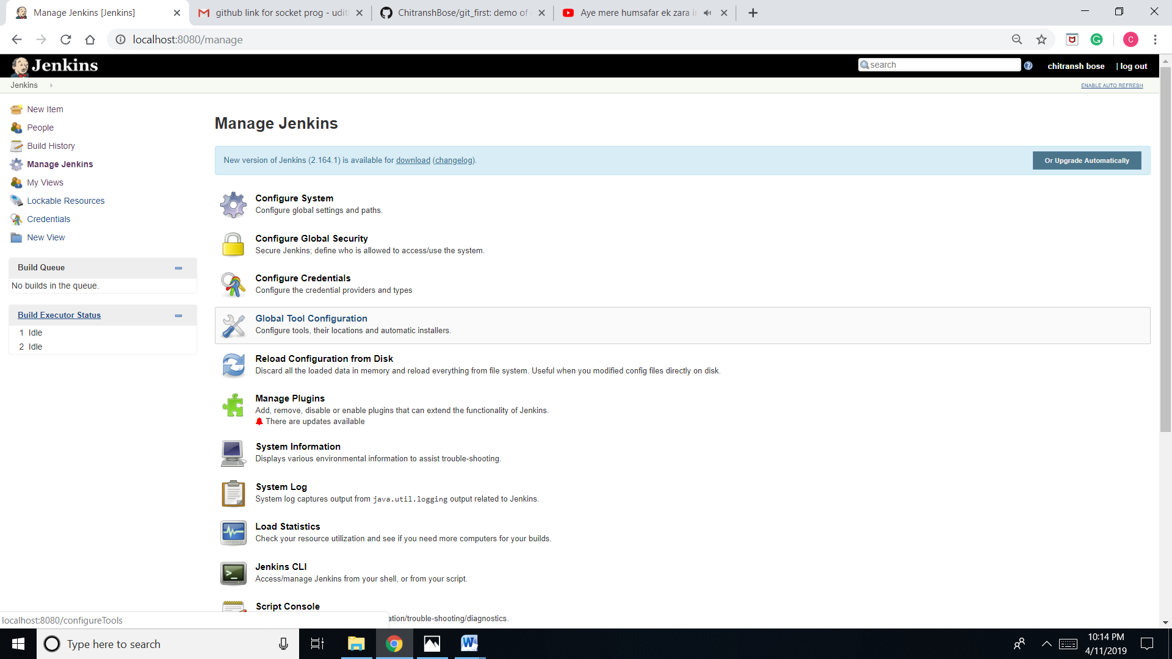Go to “manage Jenkins” and then “global tool configuration”.
2. Go to JDK and add JDK

-> Name it as myjava.

->Check on “install automatically”.

->version: java SE Development kit 8u152.

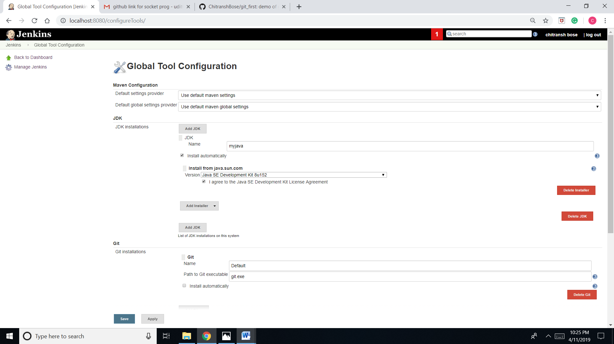->Check I agree.

1. Go to Maven.

-> add maven.

-> Name:mymaven.

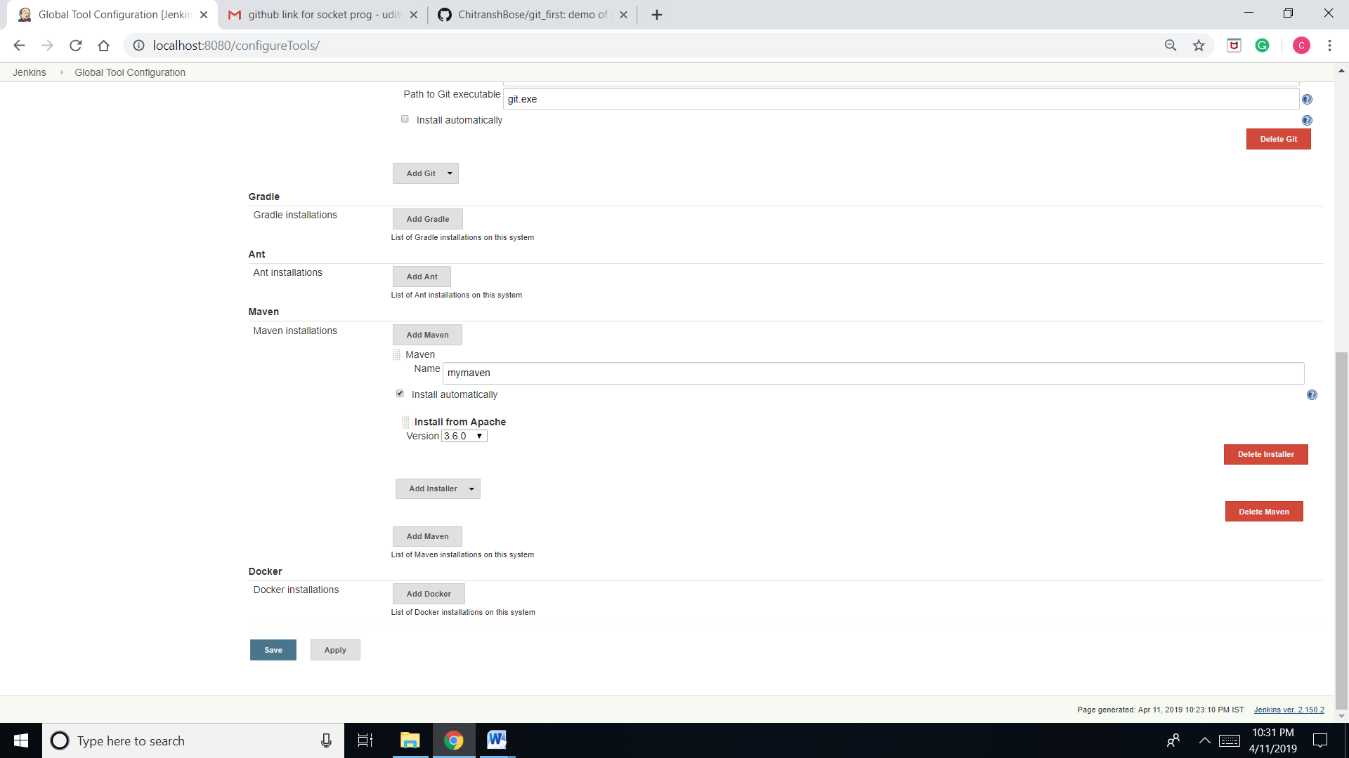-> Check install automatically and save.

1. Configure DevCompile job and then go to build and in “add build step” choose “invoke top-level”.

->maven version:mymaven.

-> Goals:compile.

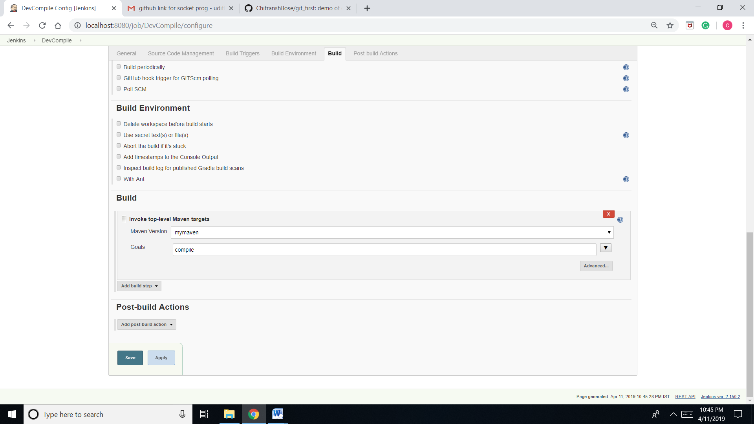

1. 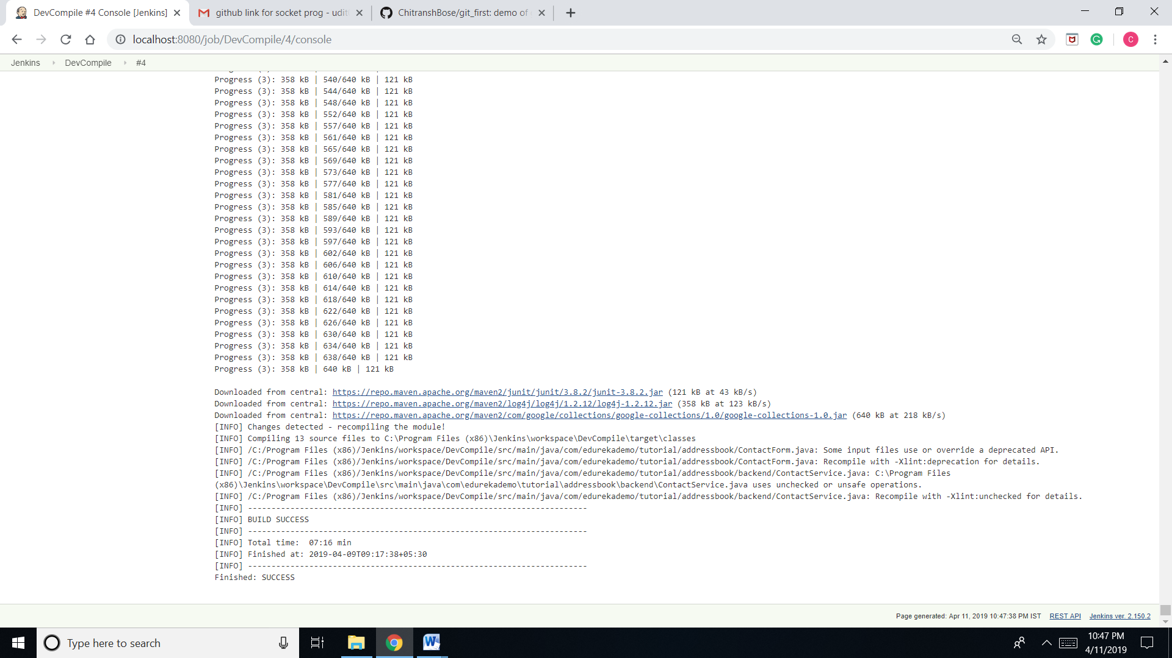Check the console output.

Task 2k.

1. 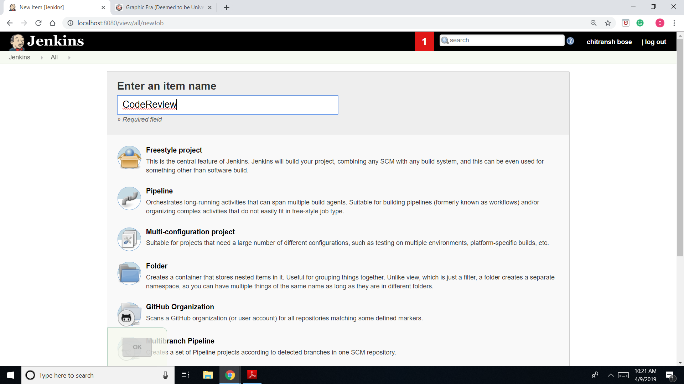Create job CodeReview and choose freestyle project.
2. In configure go to “source code management”.

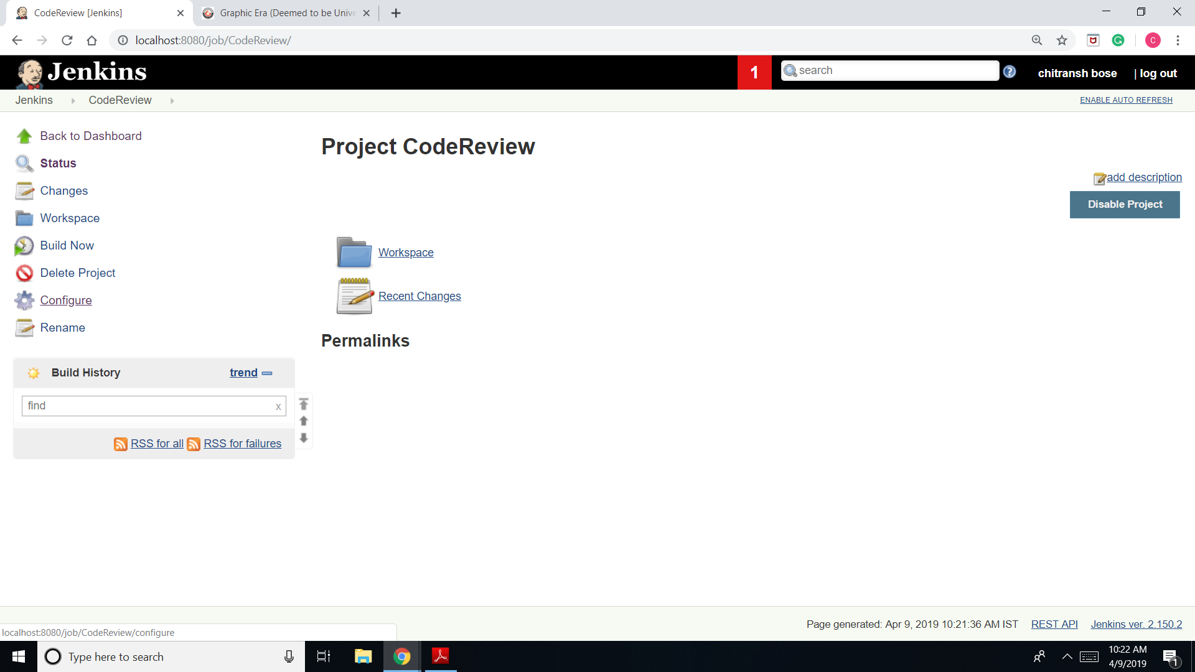

1. Choose git and in repository copy the URL: <https://github.com/edureka-git/DevOpsClassCodes.git>

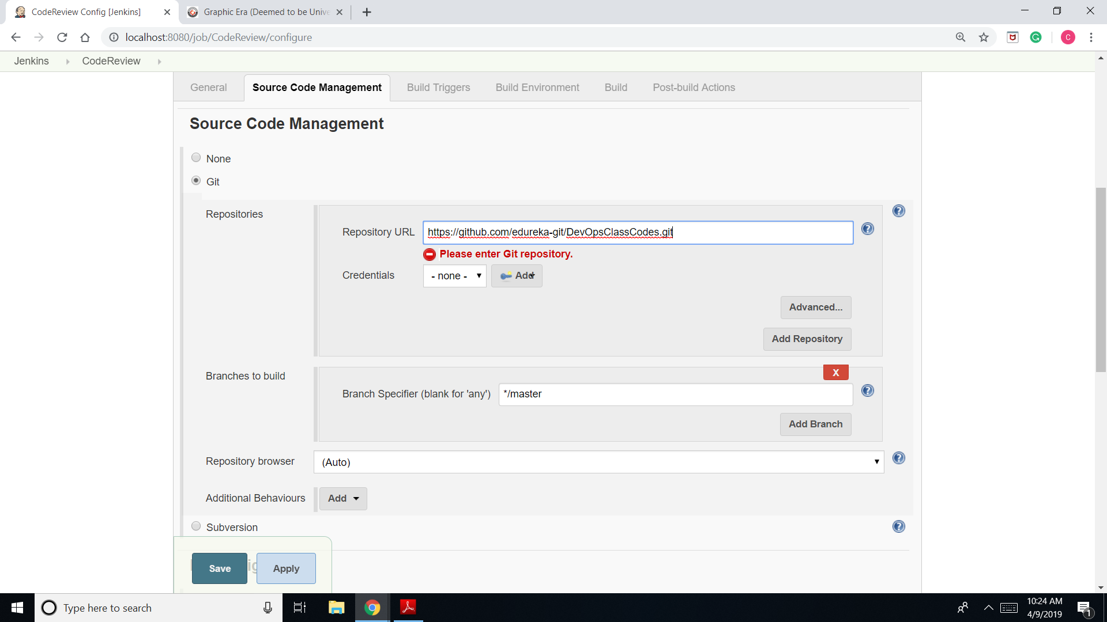

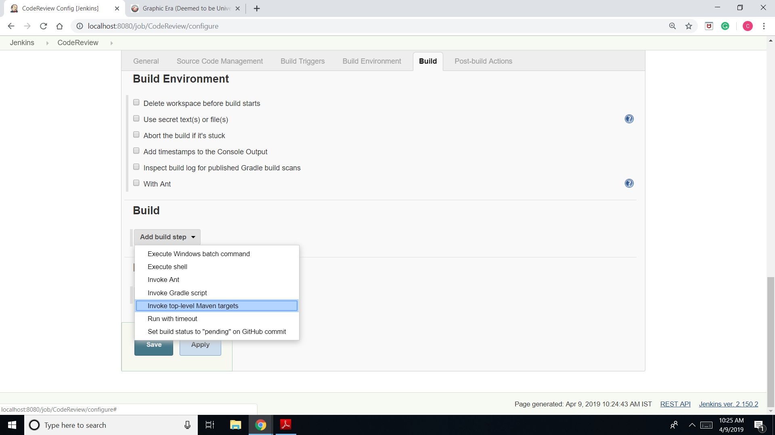

1. Go to build and add build step as “Invoke top-level Maven target”.
2. 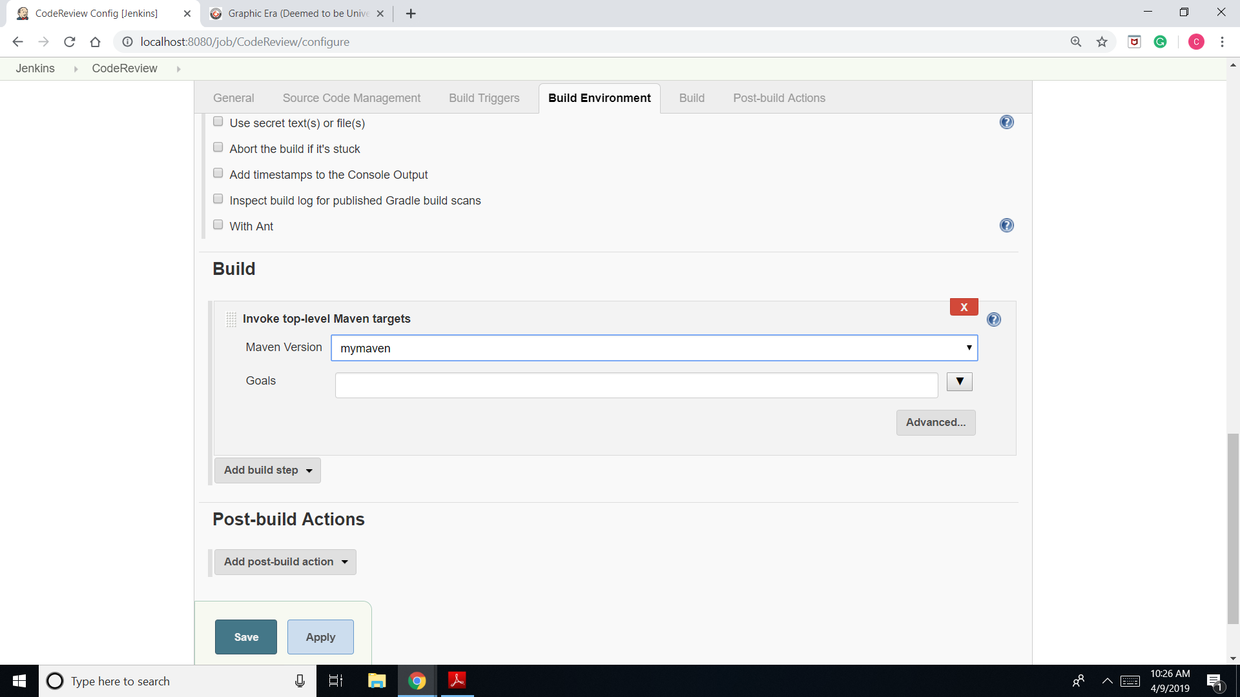Enter Maven version as myversion and Goals as P metrics pmd:pmd and save.

1. 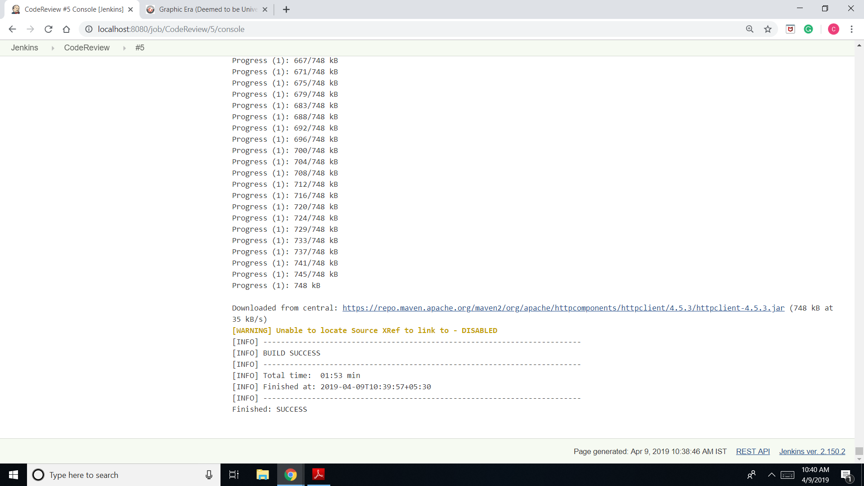Build it and check pmd.xml on workspace/target.

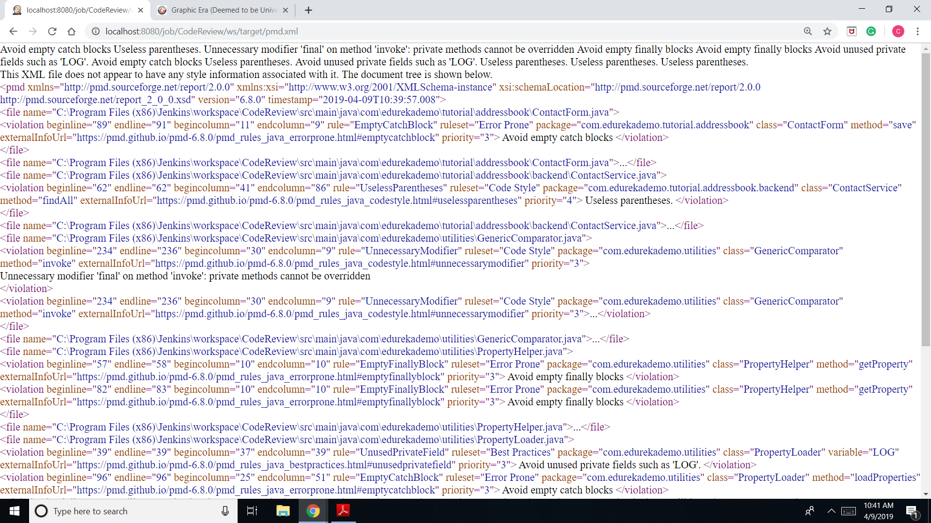

1. 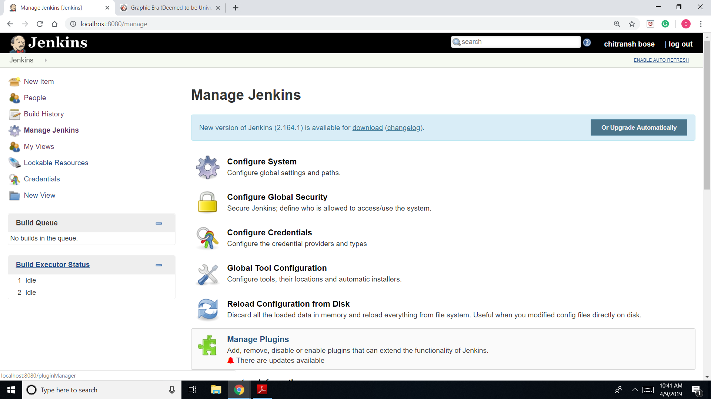Go to manage Jenkins and then manage plugins.
2. Search plugin “pmd” and install it.

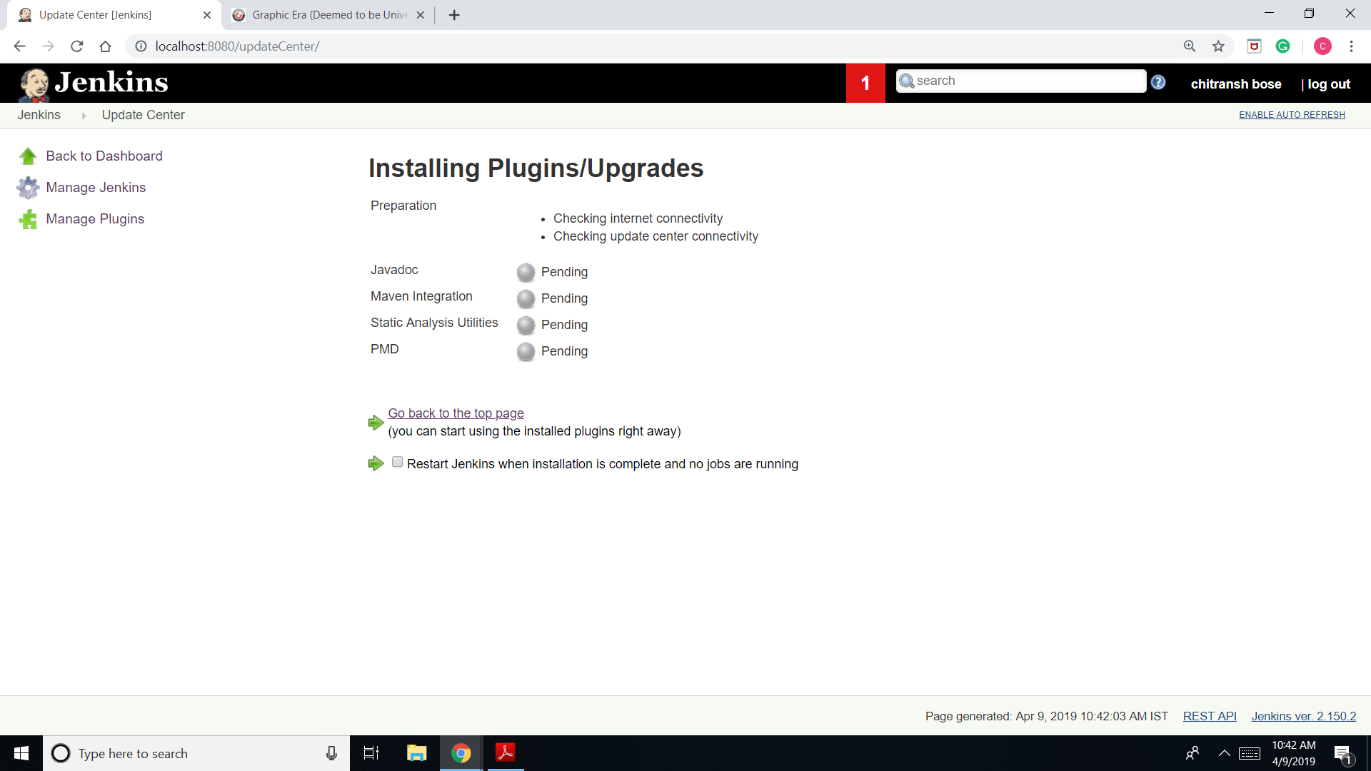

1. 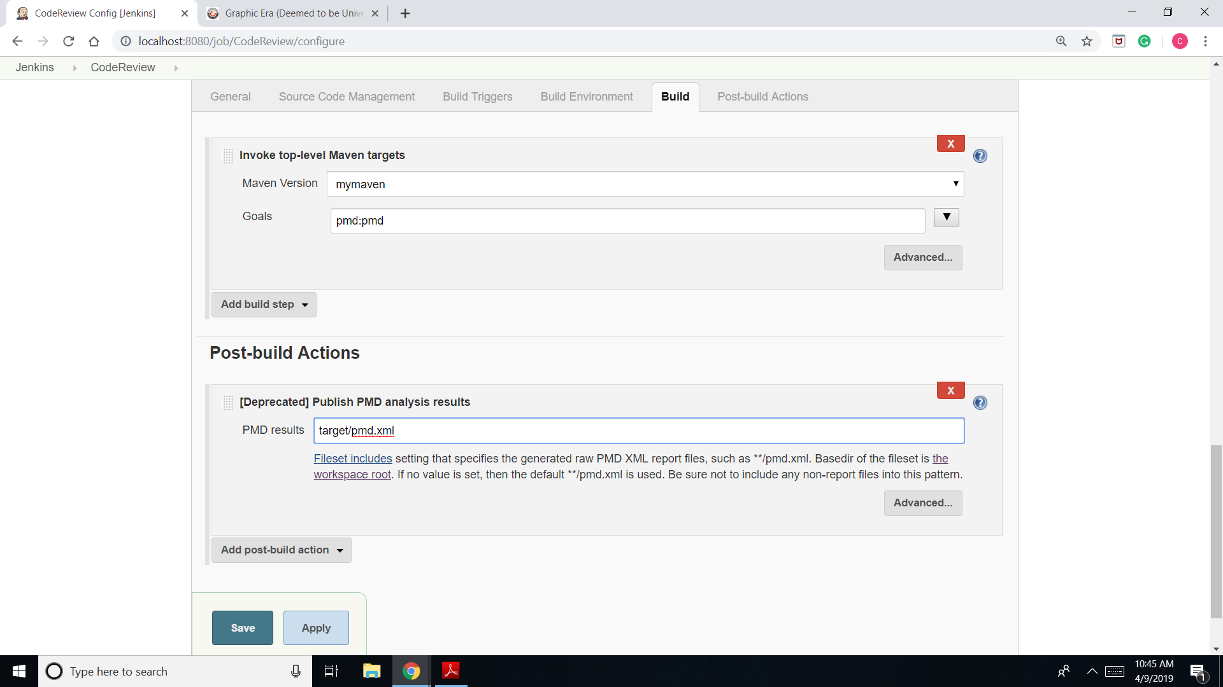Configure CodeReview and go to “post-build actions” and choose “publish pmd analysis results”.
2. 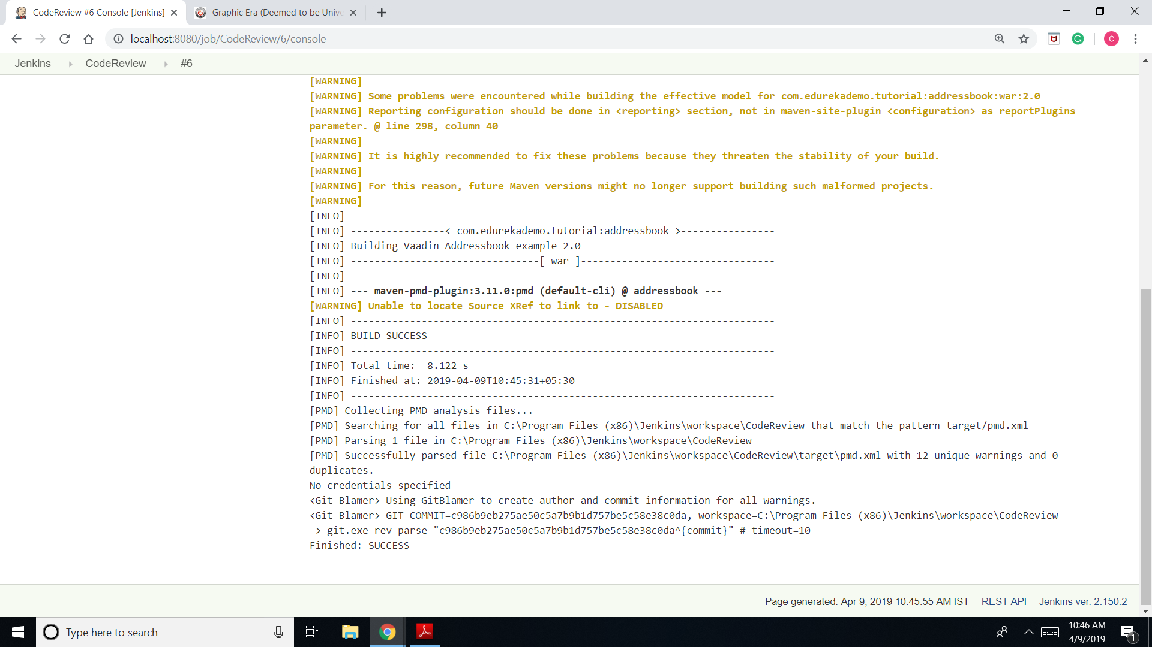Save, build and check the analysis under PMD warnings.